*I N D E X*

|  |  |  |
| --- | --- | --- |
| **Sr. No** | **Description** | **Page No.** |
| 1 | Introduction | 1-3 |
|  | 1.1 Project Summary | 1 |
|  | 1.2 Project Technical Profile | 2 |
| 2 | Scopes & Planning | 4-11 |
|  | 2.1 Requirement Analysis | 4-7 |
|  | 2.2 Feasibility Study | 8 |
|  | 2.3 Timeline Chart | 9 |
|  | 2.4 Future Development | 10 |
|  | 2.5 Technology Details | 11 |
| 3 | Designing | 12-77 |
|  | 3.1 Data Flow Diagram | 12-30 |
|  | 3.2 Use Case Diagram | 31-33 |
|  | 3.3 ER Diagram | 34 |
|  | 3.4 Database Design | 35-38 |
|  | 3.5 User Interface | 39-77 |
| 4 | Testing | 78-90 |
|  | 4.1 Unit Testing | 78-85 |
|  | 4.2 Navigation Testing | 86-88 |
|  | 4.3 Functional Testing | 89 |
|  | 4.4 Environment Testing | 90 |
| 5 | Conclusion | 91 |
| 6 | Bibliography | 92 |



#### Introduction

* 1. Project Summary

In day to day life, we will need to buy lots of goods or products from a shop. It may be food items, electronic items, house hold items etc etc. Now a days, it is really hard to get some time to go out and get them by ourselves due to busy life style or lots of works. In order to solve this, B2C E- Commerce websites have been started. Using these websites, we can buy goods or products online just by visiting the website and ordering the item online by making payments online.

All in one store is a website that provide to buy Home,Mobiles,Electronic,fresh,fashion item ,etc. it's Good/Trusted & Tension free delivery services. Products bought online will be delivered to the footsteps of the buyer free of cost(may be varied based on the vendor/seller).Reports generated can be saved for future references.

This existing system of buying goods has several disadvantages. It requires lots of time to travel to the particular shop to buy the goods. Since everyone is leading busy life now a days, time means a lot to everyone. Also, there are expenses for travelling from house to shop. More over the shop from where we would like to buy something may not be open 24*7*365. Hence, we have to adjust our time with

the shopkeeper’s time or vendor’s time.

In order to overcome these, we have e-commerce solution, i.e., one place where we can get all required goods/products online. The proposed system helps in building a website to buy, sell products or goods online using internet connection. Purchasing of goods online, user can choose different products based on categories, online payments, delivery services and hence covering the disadvantages of the existing system and making the buying easier and helping the vendors to reach wider market.

* 1. **Project Technical Profile**

|  |  |
| --- | --- |
| **Project Title:** | All in one store |
| **Definition :** | Online shopping is a form of electronic commerce which allows consumers to directly buy goods or services from a seller over the Internet using a web browser . |
| **Developed For :** | S.D. J. International College, Vesu , Surat |
| **Project Guide(s):** | Prof. Bhumika Patel |
| **Front End:** | Html, css ,Javascript |
| **Scripting language :** | Php |
| **Back End :** | Mysql |
| **Operating System:** | Microsoft Windows 10 |
| **Designing Tools** |  |

|  |  |
| --- | --- |
| **Tools used for ERD & DFD** | Visio Templates | Poly, formerly Plantronics & Polycom |
| **Submitted By** | 1. Jadav manoj odhavjibhai 2. Khathiriya utsav alpeshbhai 3. Mangukiya mit vrajlal |



#### Scopes & Planning

* 1. Requirement Analysis

To develop any web application system, it is most important to identify the user requirement in very specific manner. Also to function properly, all interfaces of proposed system with surrounding system must be identified. The correct system is that satisfied all users requirement. Therefore, it is very important to analyse the existing system and to document the software requirement specification for proposed system which in turn provides the base for development of the proposed system.

Our project guide conducted a series of lectures to impart us the required knowledge about the system. During the lectures, we also had question and answer session at the end, which helped us to have a clear idea about the Expected system.

Fact Gathering Techniques:

Fact –finding is the job of a person or group of person in administrative proceedings that has or have the responsibility of determining the facts relevant to decide a controversy. The term trier of fact gathering denotes the same function the process is an extremely important part of the communication process.

They are:

* + 1. Interviewing
    2. Questionnaires
    3. Records inspection
    4. Observation

Interviewing:

* This method is used to collect the information from groups or individuals. Analyst selects the people who are related with system for the interview.
* In this method the analyst sits face to face with the people and records their responses.
* All basic requirements are conducted at this stage.
* It is a basic source of qualitative information.

Questionnaires:

* It is the technique used to extract information from number of people. This method can be adopted and used only by an skillful analyst.
* The questionnaires consists of series of question framed together in logical manner
* In this, we get all information related to student fees collects related information.
* Gathering some data.

Record Review:

* Records review is used to revise all the requirements before implementation.
* Here we revise all systems requirements like design & view of system facilities ,policies , terms & condition ,time-duration and all .
* Background reading or research is a part of the process.

Observation:

* Unlike the other fact finding techniques, in this method the analyst himself vis- its the organization and observe and understand the flow of documents, working of existing System, the user of the system.
* At this stage, we consider all design & data related information like how to shows our form, which kind of interface gives to user & going with all this.

Conclusion of fact finding technique :

* I am use observation technique.
* I use all above for technique to find and gathering information related to system but I use most observation technique.

Functional requirement (Admin)

* + Admin manage facility for insert, update, and delete category, and type.
  + Admin can also manage registration, verification process of user who registers.
  + Admin manage facility for insert, update and delete products.
  + Admin can display facilities for product orders have.
  + Admin can Manage product stock ,category of products , invoice of orders.
  + Admin can manage sub admin details like id, email id, photo etc.
  + Admin can also add and remove sub admin.
  + Admin can show the users details, Total number oforder and total amount .
  + Admin can Change his profile.

Functional requirement (sub admin)

* Admin can register sub admin .
* Sub admin have to get Approval from Admin then Only he /she is considering as a verified sub admin.
* Verified sub admin can manage the Service Information Like products and stock of products

,orders and invoice of orders.

* Sub admin has Right on service for which he/she is Registered.
* Sub admin can show the users , Total number of order and total amount .
* Sub admin can’t Change his profile but request to admin to change profile.

Functional requirement (User)

* User can register to the All in one store process system and log in it.
* User can forget password.
* Forgot password will change password by just entering vaild email id and provide link of change the password in mail.
* User can click rembember buttons in day often not entre email id and password to login website .
* If any inquiry or details are required then the user can also contact sub admin regarding Particular service.
* User can get Response for his Query from Admin or subadmin.
* User can also check product Details on the website who uploaded by admin and sub admin .
* User can added the products on cart which he/she will be buy products .
* User can see the products .
* User can also has right to cancel order.
* User , which products are brought, can download invoice .
  1. Feasibility Study
* This activity is design to help to do initial operational, technical, schedule & economic feasibilityevaluation of the project and also practice these three approaches to cost benefit analysis knowledge of cost benefit analysis is critical for a successful systems analyst and also for anyone who must decide whether or not to approve a project. It is the measure of how beneficial or practical the development of information system will be to an organization.

Technical feasibility

* It is measure of practicality of a specific technical solution and the availability of technical resources and expertise. All the software needed for developing the project are like sublime with php, MySQL are already available so the system is technically Feasible.
* Technical feasibility center on the existing manual system of the test management process and to what extent it can support the system.
* According to feasibility analysis procedure the technical feasibility of system is analyzed and the technical requirements such as software
* Facilities, procedure, inputs are identified. It is also one of the important phases of the system development activities.
* The system offers greater levels of user friendliness combined with greater processing speed. Therefore, the cost of maintenance can be reduced.

2.3.Timeline Chart

|  |  |  |  |  |  |  |  |  |  |  |  |  |  |  |  |  |  |  |  |
| --- | --- | --- | --- | --- | --- | --- | --- | --- | --- | --- | --- | --- | --- | --- | --- | --- | --- | --- | --- |
| **Work Tasks** | **Jan** | | **Feb** | | | | **March** | | | | **April** | | | | | **May** | | | |
| **Week** | **3** | **4** | **1** | **2** | **3** | **4** | **1** | **2** | **3** | **4** | **1** | **2** | **3** | **4** | **1** | | **2** | **3** | **4** |
|  |  |  |  |  |  |  |  |  |  |  |  |  |  |  |  | |  |  |  |
| **1.Requironment Gathering & Analysis** |  |  |  |  |  |  |  |  |  |  |  |  |  |  |  | |  |  |  |
| 1.1 Learn PHP |  |  |  |  |  |  |  |  |  |  |  |  |  |  |  | |  |  |  |
| 1.2 Requirement Gathering |  |  |  |  |  |  |  |  |  |  |  |  |  |  |  | |  |  |  |
| 1.3 Requirement Analysis |  |  |  |  |  |  |  |  |  |  |  |  |  |  |  | |  |  |  |
| **Milestone**: Requirements Gathered. |  |  |  |  |  |  |  |  |  |  |  |  |  |  |  | |  |  |  |
| **2.Modeling** |  |  |  |  |  |  |  |  |  |  |  |  |  |  |  | |  |  |  |
| 2.1 Identifying proposed project profile. |  |  |  |  |  |  |  |  |  |  |  |  |  |  |  | |  |  |  |
| 2.2 Identifying Objectives. |  |  |  |  |  |  |  |  |  |  |  |  |  |  |  | |  |  |  |
| 2.3 Scope definition. |  |  |  |  |  |  |  |  |  |  |  |  |  |  |  | |  |  |  |
| 2.4 Review. |  |  |  |  |  |  |  |  |  |  |  |  |  |  |  | |  |  |  |
| **Milestone**: Modeling Completed. |  |  |  |  |  |  |  |  |  |  |  |  |  |  |  | |  |  |  |
| **3.System Design** |  |  |  |  |  |  |  |  |  |  |  |  |  |  |  | |  |  |  |
| 3.1 Design system flow. |  |  |  |  |  |  |  |  |  |  |  |  |  |  |  | |  |  |  |
| 3.2 Database Design. |  |  |  |  |  |  |  |  |  |  |  |  |  |  |  | |  |  |  |
| 3.3 Admin Side Design. |  |  |  |  |  |  |  |  |  |  |  |  |  |  |  | |  |  |  |
| 3.4 Sub-admin Side Design. |  |  |  |  |  |  |  |  |  |  |  |  |  |  |  | |  |  |  |
| 3.5 Client Side Design |  |  |  |  |  |  |  |  |  |  |  |  |  |  |  | |  |  |  |
| 3.6 Review. |  |  |  |  |  |  |  |  |  |  |  |  |  |  |  | |  |  |  |
| **Milestone**: System Design completed |  |  |  |  |  |  |  |  |  |  |  |  |  |  |  | |  |  |  |
| **4.Coding** |  |  |  |  |  |  |  |  |  |  |  |  |  |  |  | |  |  |  |
| 4.1 Admin Side Coding |  |  |  |  |  |  |  |  |  |  |  |  |  |  |  | |  |  |  |
| 4.2 Sub-admin Side Coding |  |  |  |  |  |  |  |  |  |  |  |  |  |  |  | |  |  |  |
| 4.3 Client Side Coding |  |  |  |  |  |  |  |  |  |  |  |  |  |  |  | |  |  |  |
| **Milestone**: Coding completed |  |  |  |  |  |  |  |  |  |  |  |  |  |  |  | |  |  |  |
| **5.Testing** |  |  |  |  |  |  |  |  |  |  |  |  |  |  |  | |  |  |  |
| 5.1 Unit Testing |  |  |  |  |  |  |  |  |  |  |  |  |  |  |  | |  |  |  |
| 5.2 Navigational Testing |  |  |  |  |  |  |  |  |  |  |  |  |  |  |  | |  |  |  |
| 5.3 Functional Testing |  |  |  |  |  |  |  |  |  |  |  |  |  |  |  | |  |  |  |
| 5.4 Environmental Testing |  |  |  |  |  |  |  |  |  |  |  |  |  |  |  | |  |  |  |
| **Milestone:** Testing Complete |  |  |  |  |  |  |  |  |  |  |  |  |  |  |  | |  |  |  |
| **6. Documentation** |  |  |  |  |  |  |  |  |  |  |  |  |  |  |  | |  |  |  |



* 1. **Future Development**
     + The All in one store provides some of the type products which are most frequently sell in e-commerce website. This system accommodates the changing needs of the seller.
     + Enhancements Of products price and discounts.
     + Developed in Application.
     + Further this website can be prolonged by merely adding up the required services and additional payment systems. Currently this website provide only admin and sub admin can manage the products and products stock and category of products further the website can extended as per the requirements of the user. This website can have prolonged by adding services such as exchange the products ,payment using debit card or credit card get 10% discounts and many more.



* 1. Technology Details

***Hardware /Software Configuration:***

* Hardware Requirement :

**Processor :** AMD Ryzen 3 2200U with Radeon Vega Mobile Gfx 2.50 GHz

**RAM :** 8.00 GB

**HDD :** 1 TB

**SSD :** 256 GB

* Software Used For Application Implementation :

**Operating System :** Windows 10 Home Single Language

**Front End :** Html , css , javascript .

**Code Behind :** PHP

**Back End :** Mysql

**Other Tools Used :** Java script, Bootstrap, Css.

#### Designing

* 1. Data flow Diagram

**Context Level Data flow diagram**

Request for login

Request for login

Request for manage stock

Request for order

Request for user

Response for login

Response for profile

Response for subadmin Response for category

Response for product

Response for manage stock

Response for order

Response for invoice

Response for user

Response for registration Response for login

Response for forget password Response for show product Response for add to cart

Response for buy now Response for checkout Response for invoice download

Response for login

Response for product Response for manage stock

ALL in one store

Response for order

Response for profile

Response for registration

Response for login

Response for forget password

Response for show product Response for add to cart

Response for buy now

Response for checkout

Response for download invoice

client

Request for invoice

Request for order

Request for manage stock

Request for product

Request for category

Request for subadmin

Request for profile

Admin

Request for profile

Request for product

SubAdmin



**1st level DFD admin side**



Request for login

1.0

Login

response

Check for login

response

Request for

manage profile

response

2.0

Manage

profile

insert data

response

Request for manage

sub -admin

3.0

Insert data

response

Manage sub-

admin

response

Request for manage

category

4.0

response Manage category

Insert data

response

Request for manage

product

5.0

response

manage

product

manage data

response

Request for

manage stock

6.0

Manage data

response

Manage

stock

response

A

admin

member

member

Sub admin



category

product

product

A



Request for manage order

Admin

7.0

manage data

Manage

order

response

order

response

Request for invoice

response

8.0

Manage invoice

manage data order

response



Request for user response

9.0

Manage user

manage data login

response



## 1st level DFD sub-admin side

Sub-admin



Request for login

1.0

Login

response

Check for login

response

Request for edit

profile

2.0

Manage profile

response

manage data

response

Request for manage

product

3.0

response

Manage

product

Insert data

response

Request for manage

stock

4.0

response

Manage

stock

Insert data

response

Request for manage

order

5.0

response

Manage

order

manage data

response

Sub-admin

Sub-admin

product

product

order

**1st level DFD user side**

Request for



registration

1.0

Check for login

user

response

Registration

response

login

Request for login response

2.0

Login

verified data

response

login

Request for forget password

3.0

Insert data



login

response

Forget password

response

Request for show product

4.0

Insert data

response

Product

product

show

response

Request for add to

cart

5.0

manage data

Add to cart

cart

response

product

response

Request for buy

product response

6.0

Buy now

Manage data

response

order

Request for checkout order

7.0

insert data

response

Checkout order order

response



A



order



A

Request for download

invoice

response

8.0

Invoice download

manage data

response

user

## 2nd level DFD admin side(login)



Request for login

1.1

Check for login

Login

response

response

admin

member



# 2nd level DFD admin side(manage profile)

###### member



Request data for

update profile

2.1

Request data for

update profile

response

Update

profile

response

Request for update

password

2.2

Update password

manage data

response

response

Request for delete

profile

2.3

response

Delete

profile

delete data

response

admin

member

###### member



**2nd level DFD admin side(manage sub-admin )**



Request for add

sub-admin

3.1

Insert data

response

Add sub-

admin

response

Request for update

Sub-admin

3.2

Update Sub-admin

update data

response

response

Request for delete

Sub-admin

3.3

response

Delete

Sub-admin

delete data

response

admin

Subadmin

Subadmin

Subadmin



**2nd level DFD admin side(manage category )**



Request for add

category

4.1

Insert data

Add category

response

response

Request for update

category

4.2

Update category

update data

response

response

Request for delete

category

4.3

response

Delete

category

delete data

response

admin

category

category

category



**2nd level DFD admin side(manage product )**



Request for add

product

5.1

Insert data

Add product

response

response

Request for update

product

5.2

Update product

update data

response

response

Request for delete

product

5.3

response

Delete

product

delete data

response

admin

product

product

product

##### 



**2nd level DFD admin side(manage stock )**



Request for add

product stock

6.1

Insert data

response

Add product

stock

response

Request for update

Product stock

6.2

Update Product stock

update data

response

response

Request for delete

Product stock

6.3

response

Delete

Product stock

delete data

response

admin

product

product

product

**2nd level DFD admin side(manage order)**



Request for view

order

7.1

manage data

view order

response

response

admin

order



**2nd level DFD admin side(manage invoice)**



Request for view

invoice

8.1

manage data

view invoice

response

response

admin

order

### 2nd level DFD admin side(manage user)



Request for view

user

9.1

manage data

view user data

response

response

admin

login



**2nd level DFD sub-admin side(login)**



Request for login

1.1

Check for login

Login

response

response

subadmin

subadmin

# 2nd level DFD subadmin side(manage profile)

###### subadmin



Request data for

update profile

2.1

Request data for

update profile

response

Update

profile

response

Request for update

password

2.2

Update password

manage data

response

response

Request for delete

profile

2.3

response

Delete

profile

delete data

response

subadmin

subadmin

###### subadmin



**2nd level DFD subadmin side(manage product )**



Request for add

product

3.1

Insert data

Add product

response

response

Request for update

product

3.2

Update product

update data

response

response

Request for delete

product

3.3

response

Delete

product

delete data

response

subadmin

product

product

product



**2nd level DFD subadmin side(manage stock )**



Request for add

product stock

4.1

Insert data

response

Add product

stock

response

Request for update

Product stock

4.2

Update Product stock

update data

response

response

Request for delete

Product stock

4.3

response

Delete

Product stock

delete data

response

subadmin

product

product

product



### 2nd level DFD subadmin side(manage order)



Request for view

order

5.1

manage data

view order

response

response

subadmin

order

### 2nd level DFD user side(registration)



Request for

registration

1.1

insert data

registration

response

response

user

login



### 2nd level DFD user side(login)



Request for login

2.1

Login

response

Check for login

response

user

login

### 2nd level DFD user side(forget password)



Request for forget

password

3.1

Forget password

response

Update the data

response

user

login

### 2nd level DFD user side(product show)



Request for show

product

4.1

Show product

response

Show product

response

user

product



### 2nd level DFD user side(manage add to cart )



Request for add

product in cart

5.1

Insert data

response

Add product in

cart response

Request for update

Product in cart

5.2

Update Product in cart

update data

response

response

Request for delete

Product in cart

5.3

response

Delete

Product in cart

delete data

response

user

cart

cart

cart

### 2nd level DFD user side(buy now )



Request for buy

product

6.1

Product buy

response

product buy

response

user

product



### 2nd level DFD user side(checkout order )



Request for

checkout order

7.1

Checkout order

response

insert data

response

user

Order

### 2nd level DFD user side(invoice download )



Request for

download invoice

8.1

request for

download

response

Invoice download

response

user

Order



* 1. **Use case diagram :**

**Admin:**

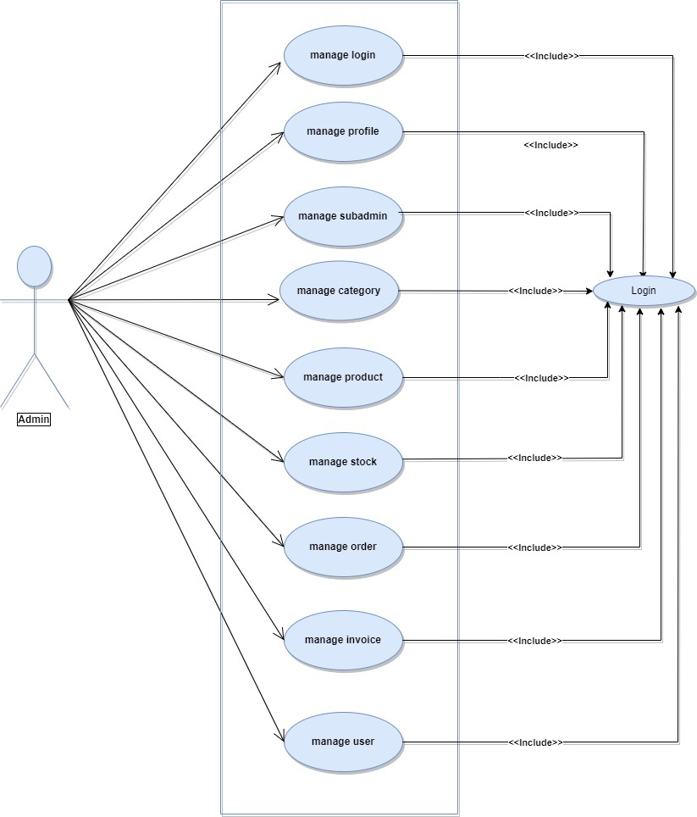



**Sub-admin :**

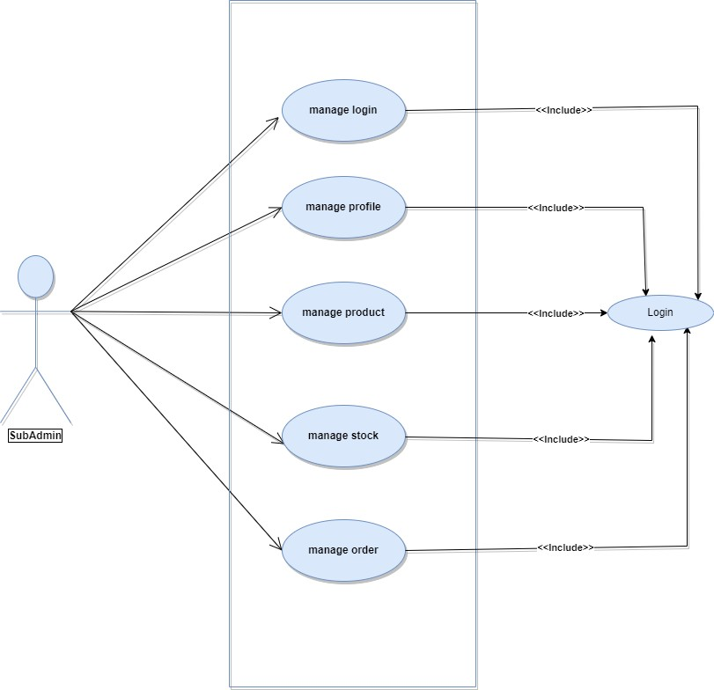

**User :**

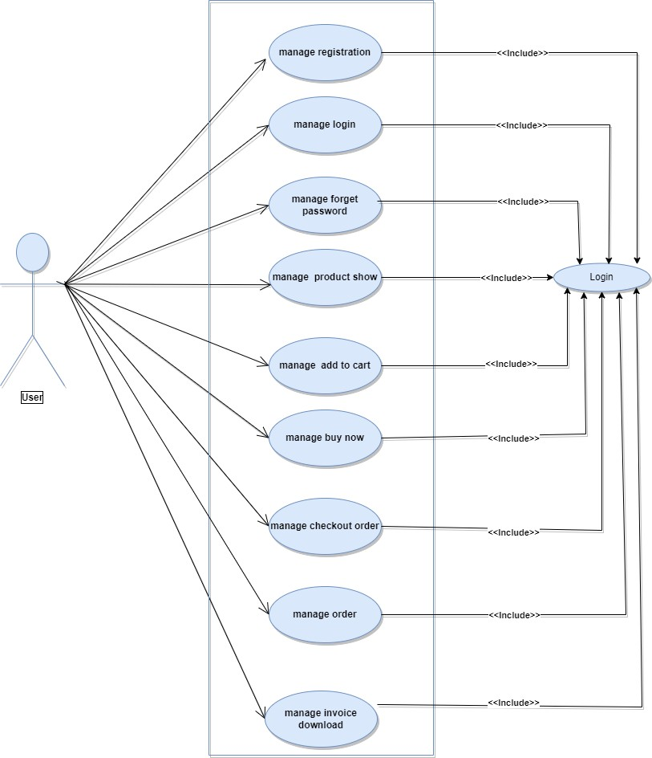



* 1. ER-Diagram

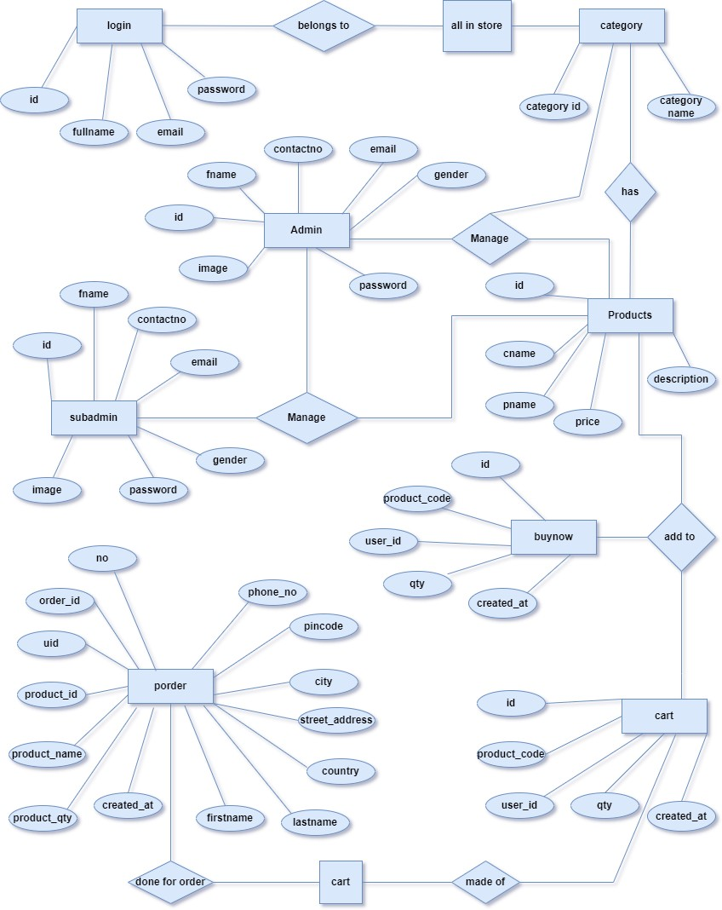



* 1. **Database Design**

**Entity Tables :-**

1. **Login(user table):**

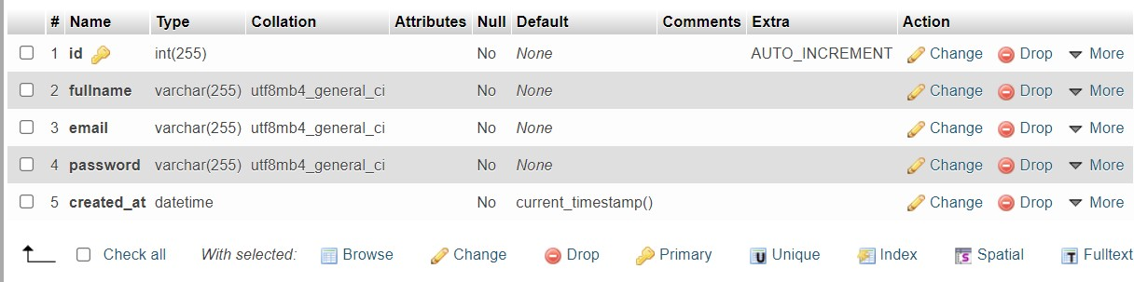

1. **product table**

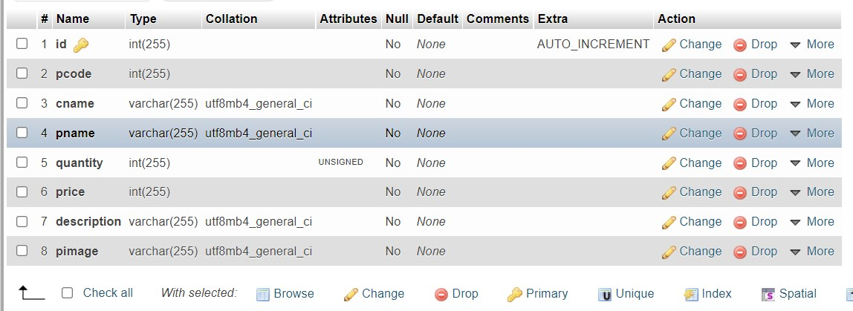



1. **cart table :**

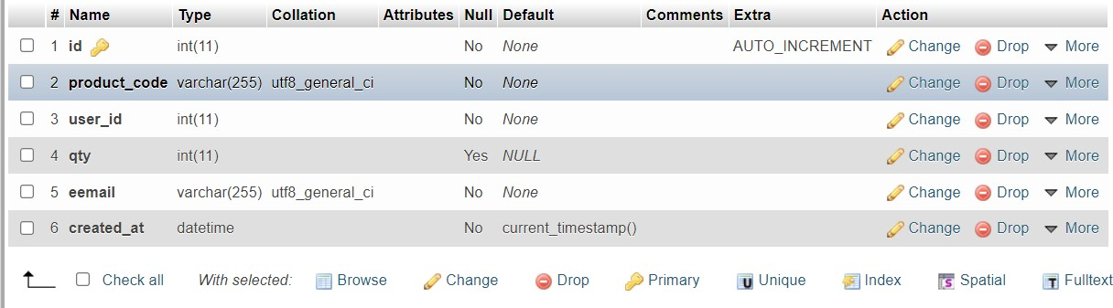

1. **Porder table :**

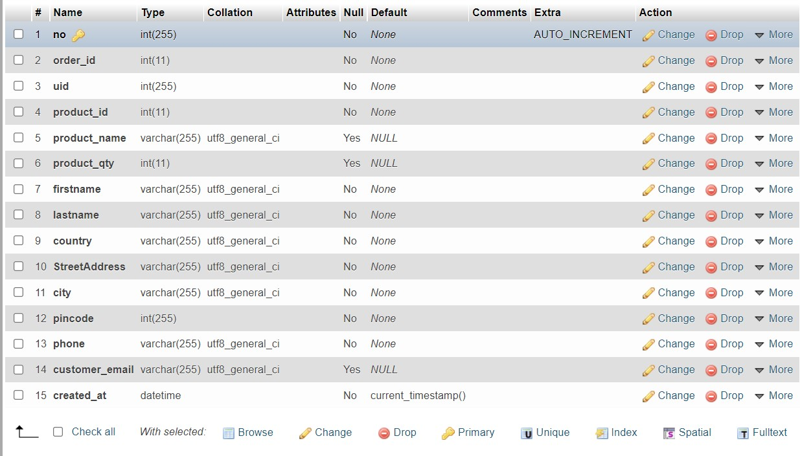



1. **Buynow table:**

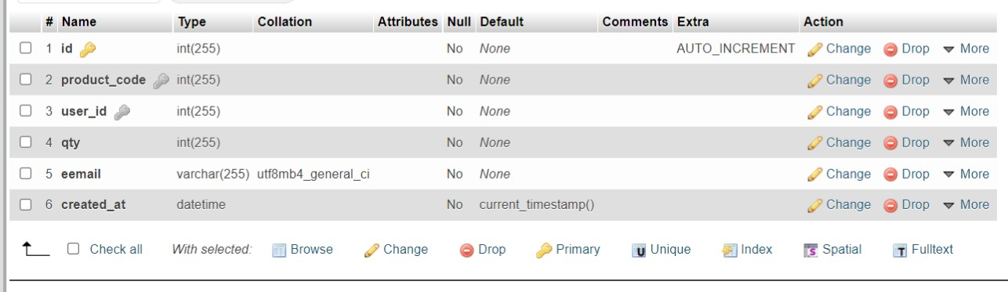

1. **Category table:**

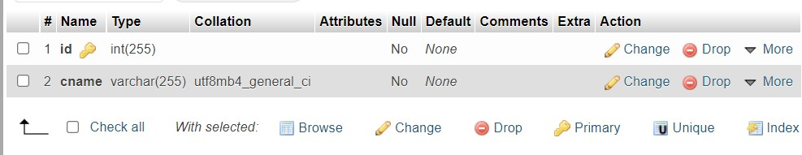



1. **Member table :**

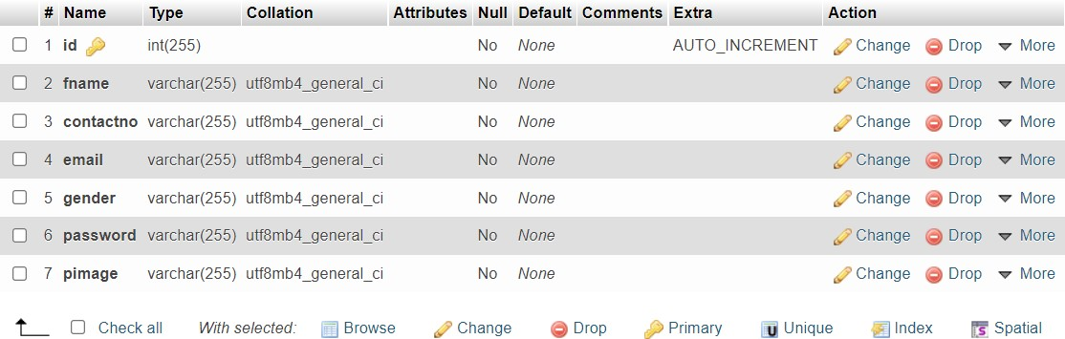

1. **Subadmin table:**

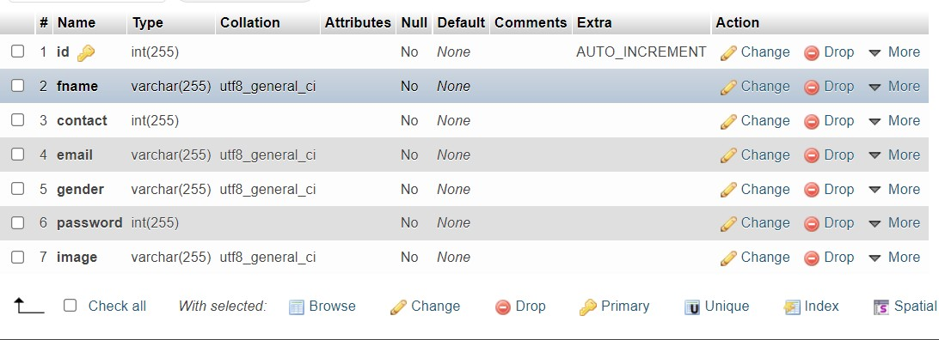

* 1. **User Interface**

# Admin side :



* 1. **Admin Login :-**

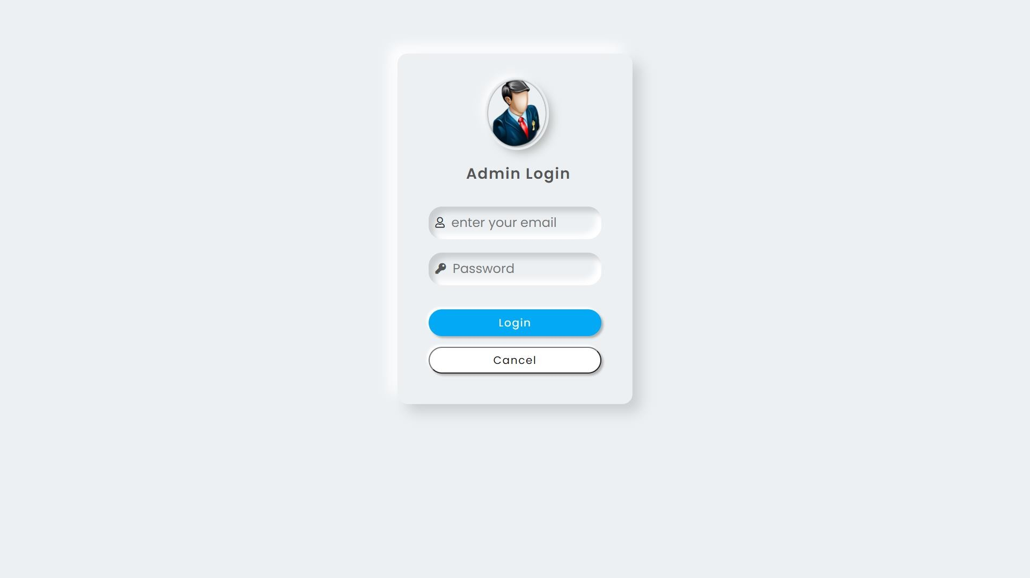

**[ Admin Login Page ]**



1. **Admin Dashboard :**

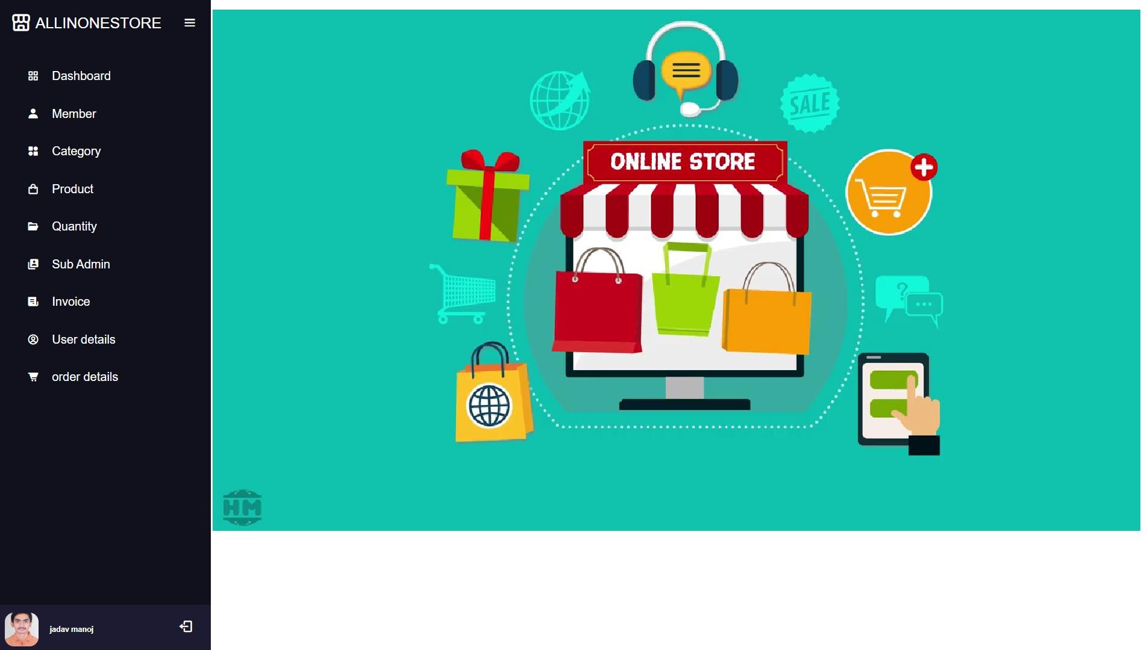

**[ Admin side Dashboard ]**



1. **Member page:**

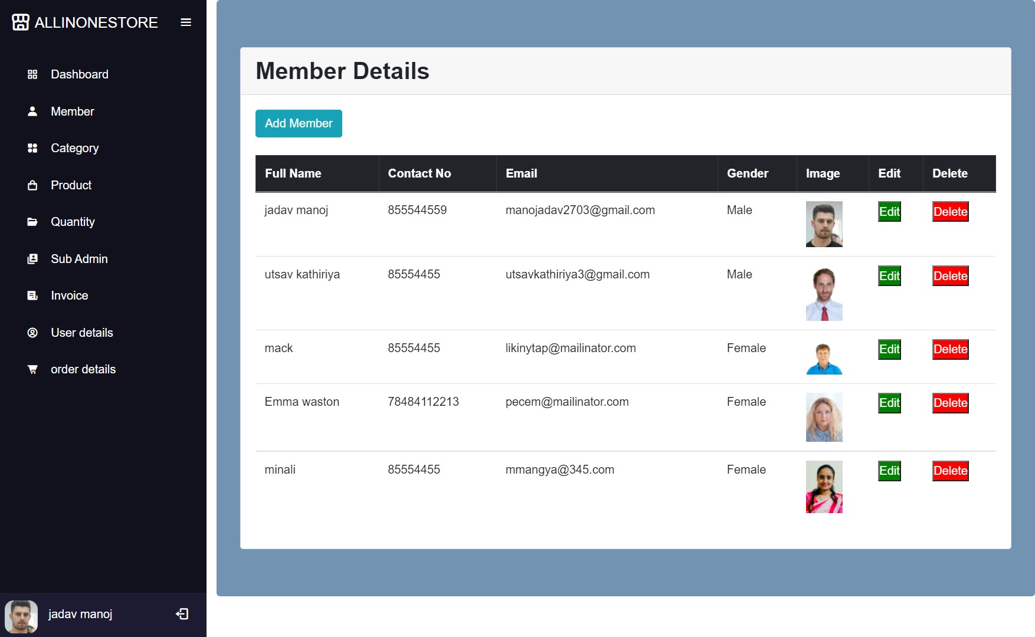

**[ Admin side Member page]**



1. **Member page:**

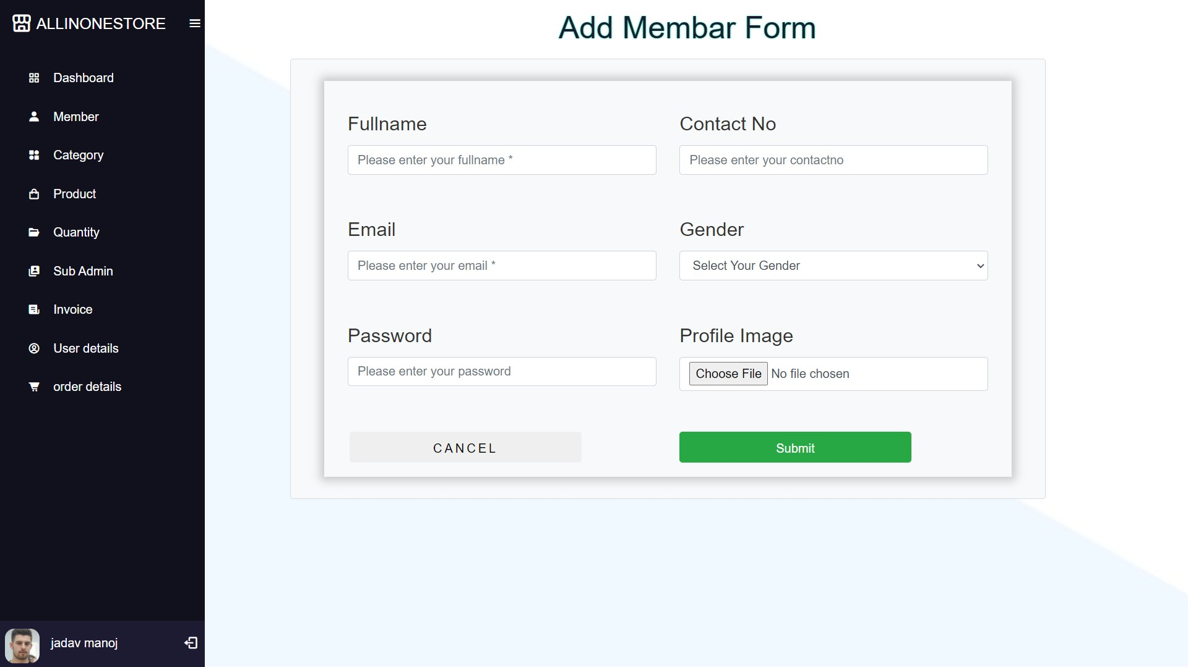

**[ Admin side Add Member page]**

1. **Member page:**

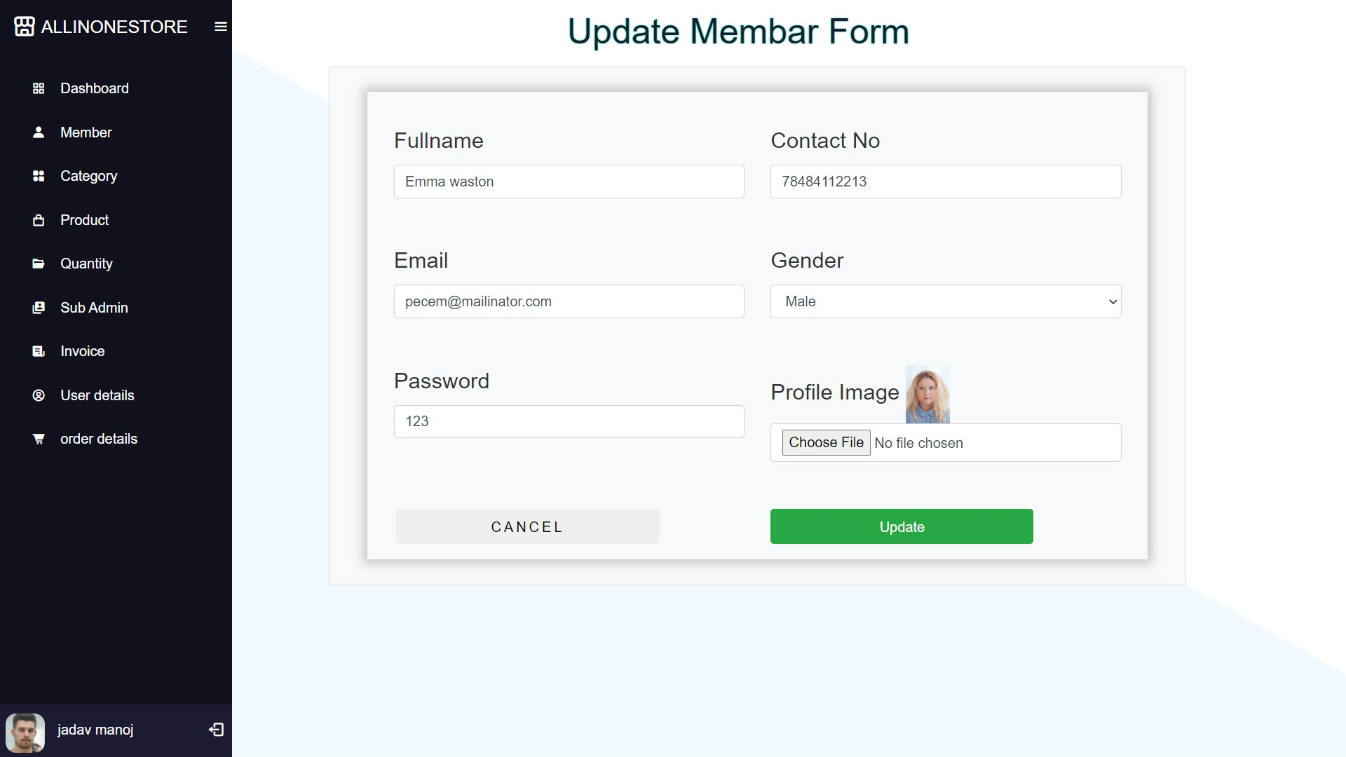

**[ Admin side Member Update page ]**



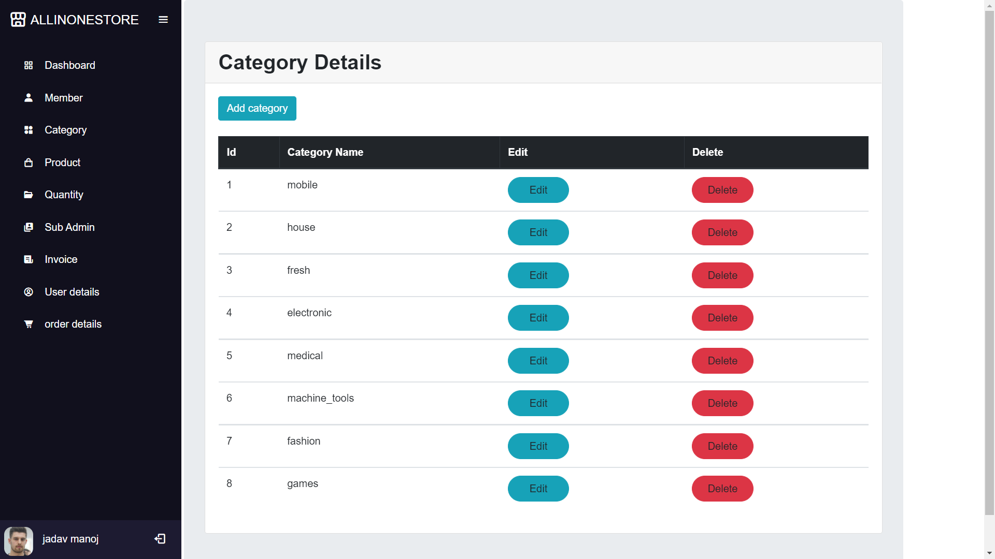

**[ Admin side Category Page ]**



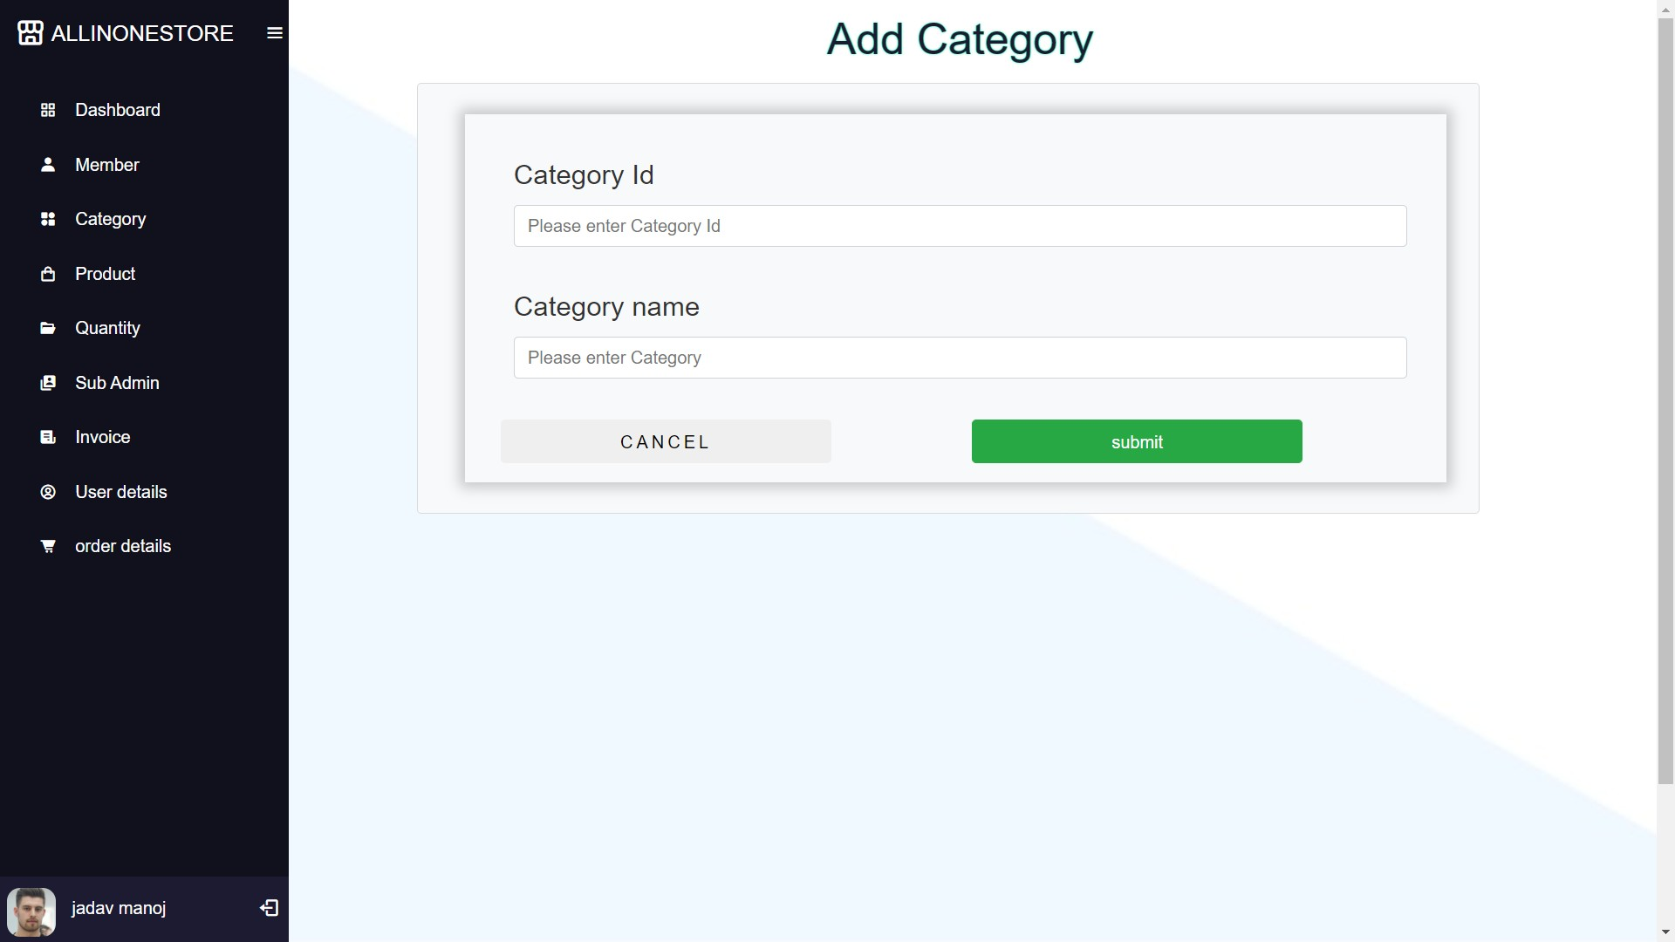

**[ Admin side Add Category Page ]**



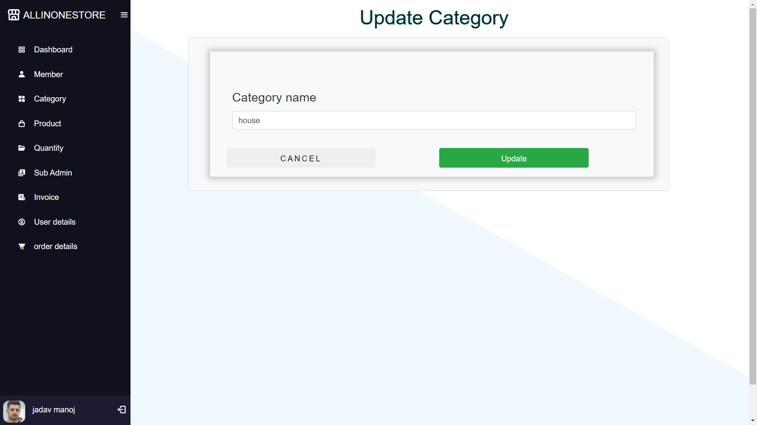

**[ Admin side Update Category Page ]**



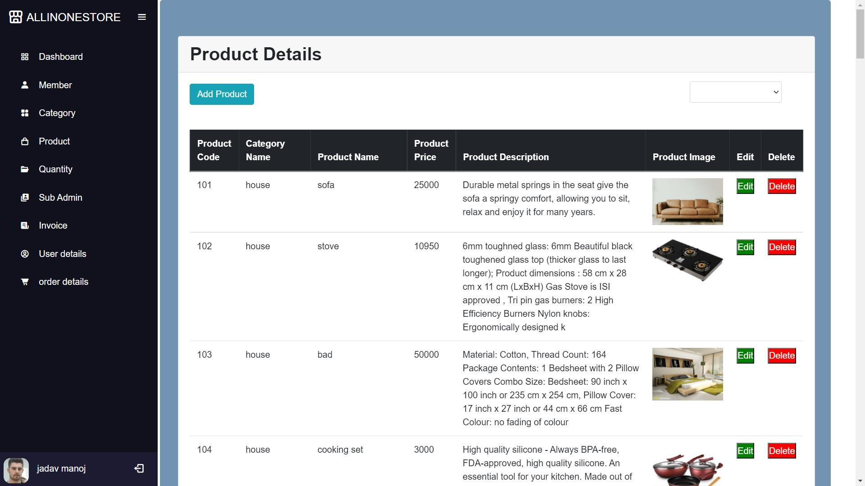

**[ Admin side Product page ]**



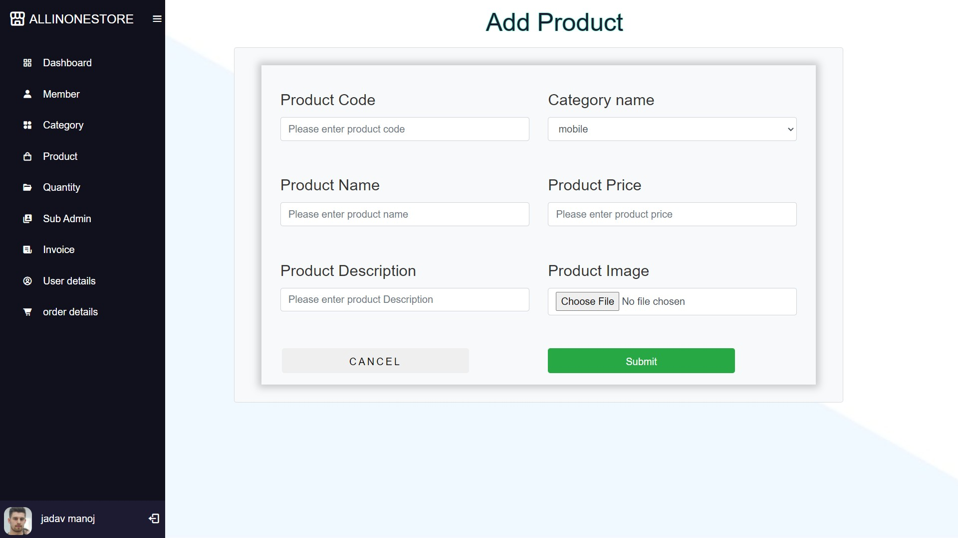

**[ Admin side Add Product page ]**

1. **Product page:**

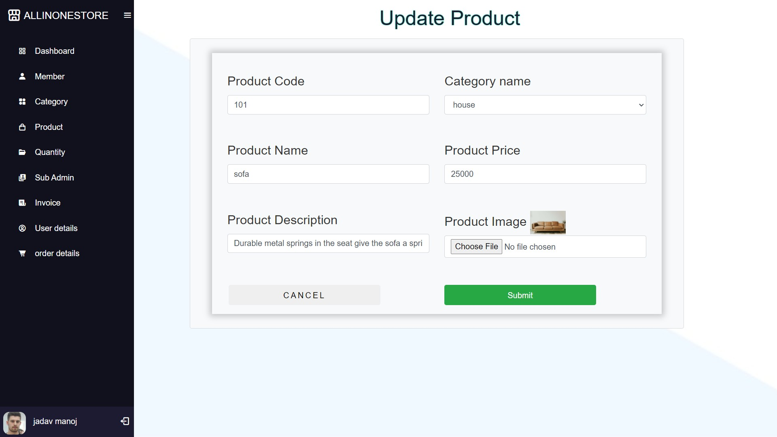

**[ Admin side Update Product page ]**



1. **Product stock page:**

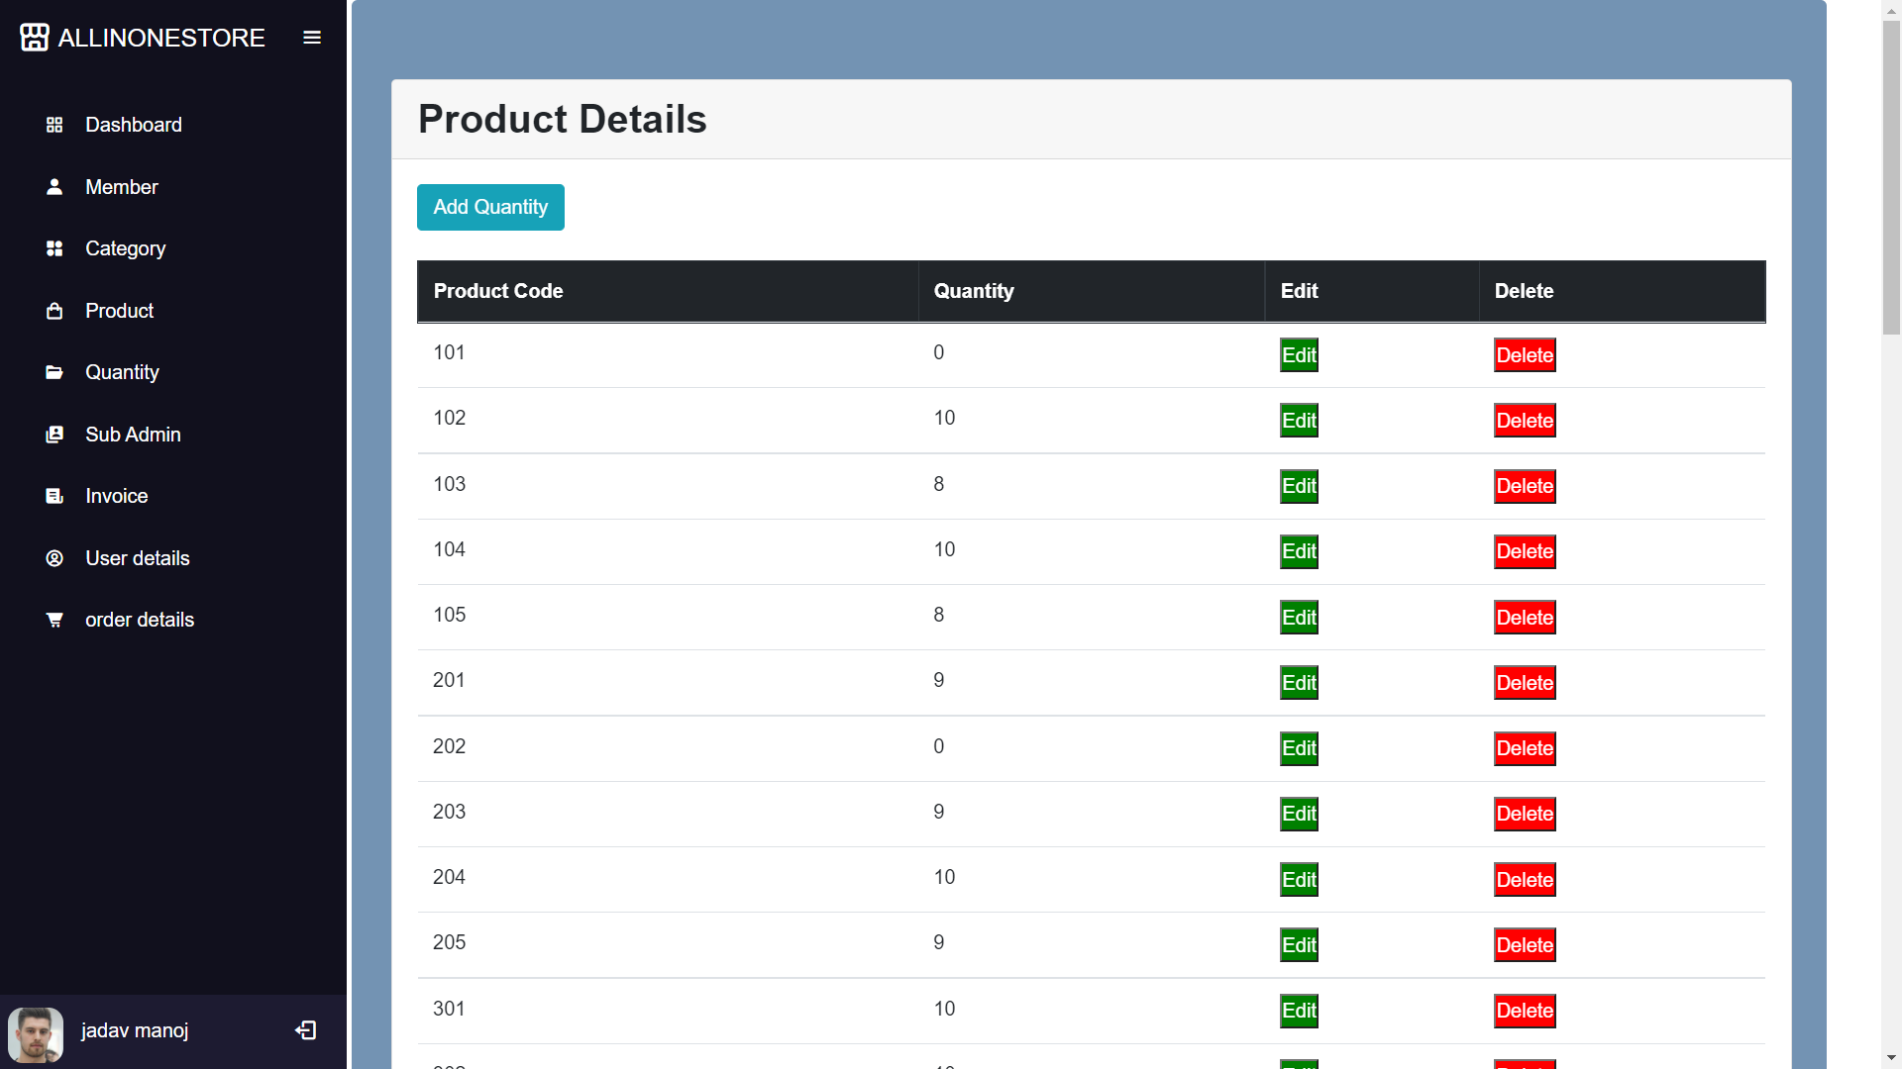

**[ Admin side Product stock page ]**



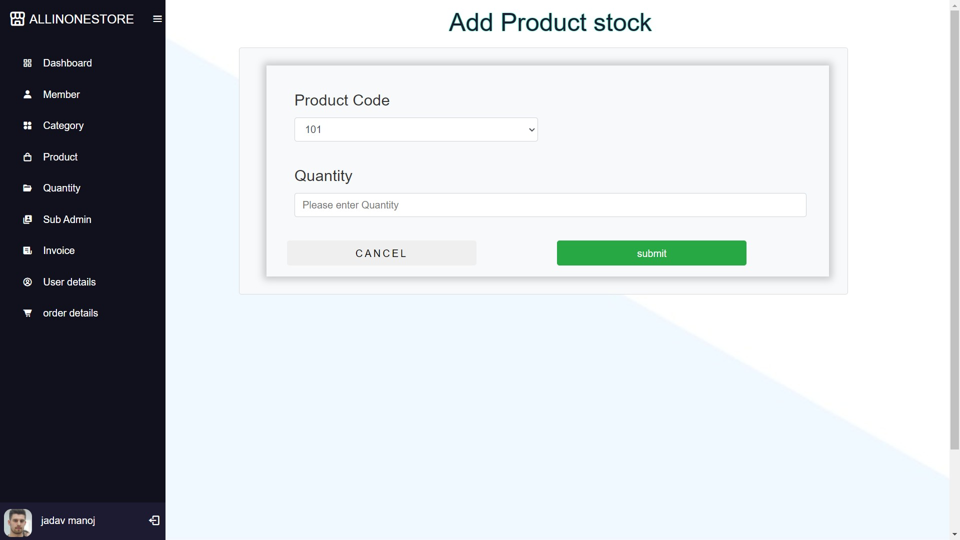

**[ Admin side Add Product stock page ]**



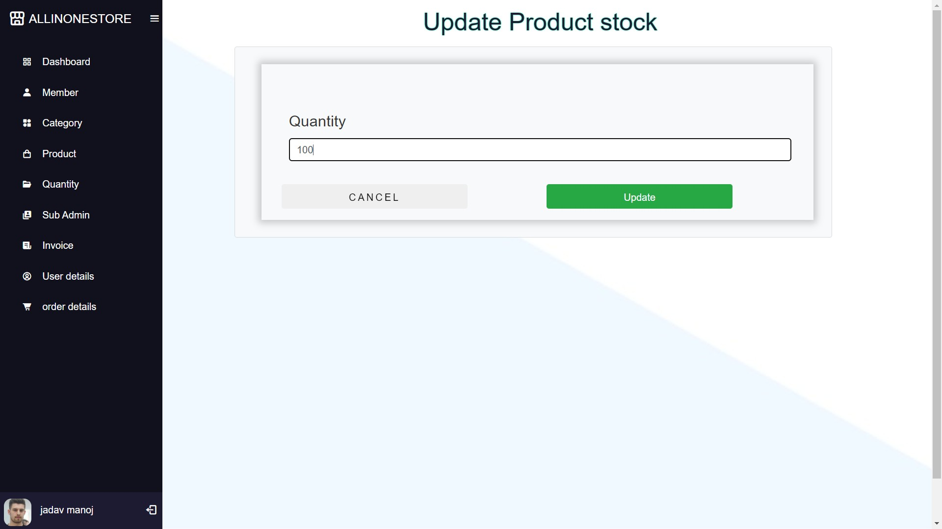

**[ Admin side Update Product stock page ]**

**15.Sub-admin page:**

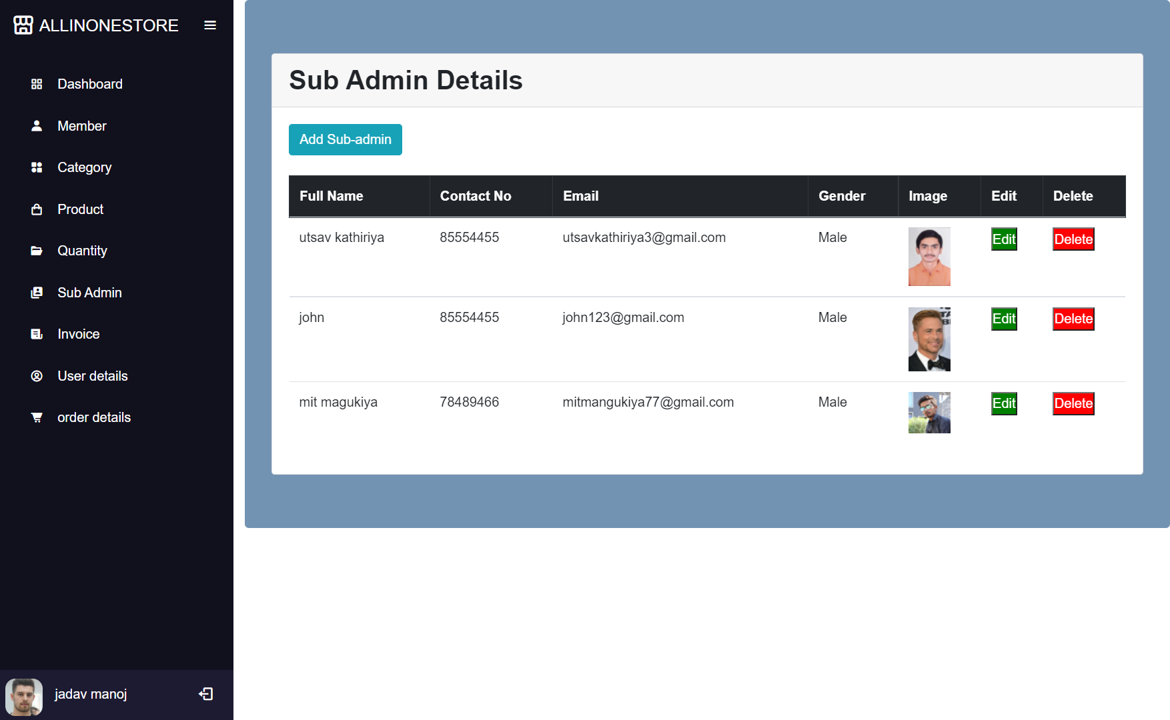

**[ Admin side Sub-admin page ]**



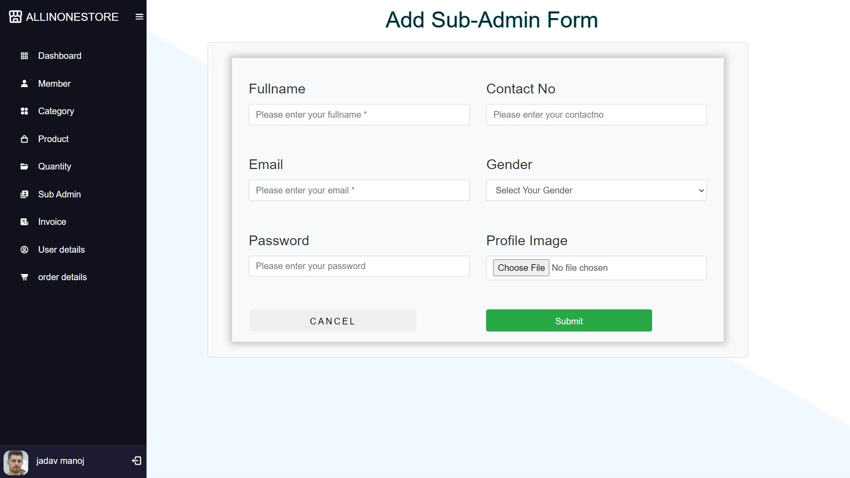

**[ Admin side Add Sub-admin page ]**



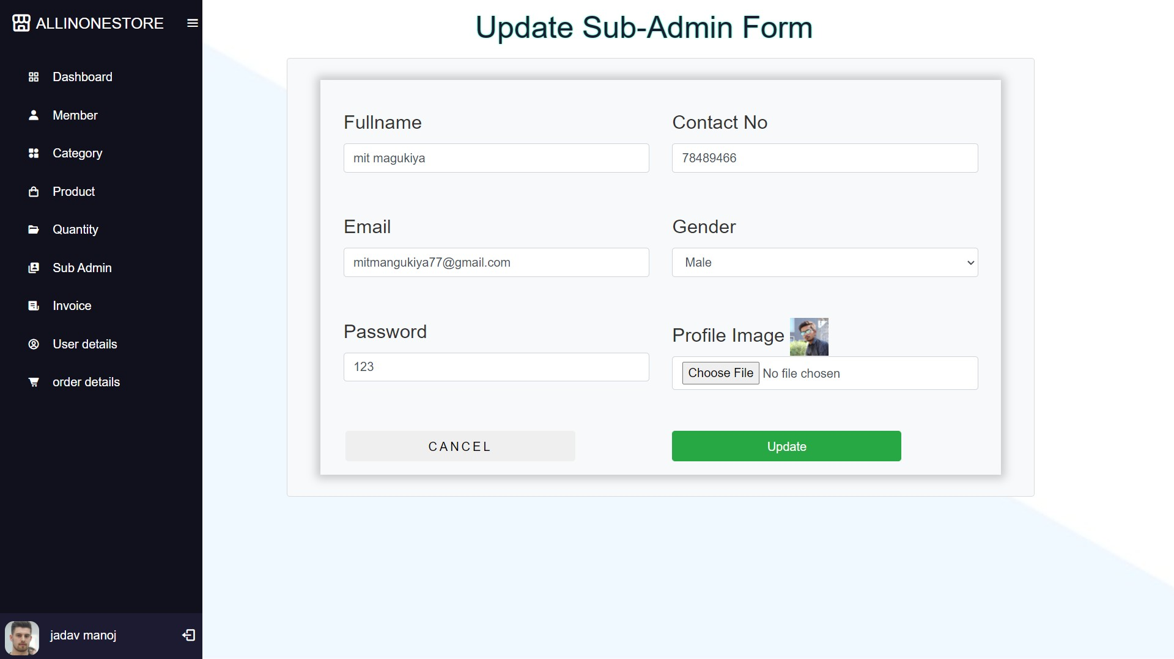

**[ Admin side Update Sub-admin page ]**



1. **Invoice page:**

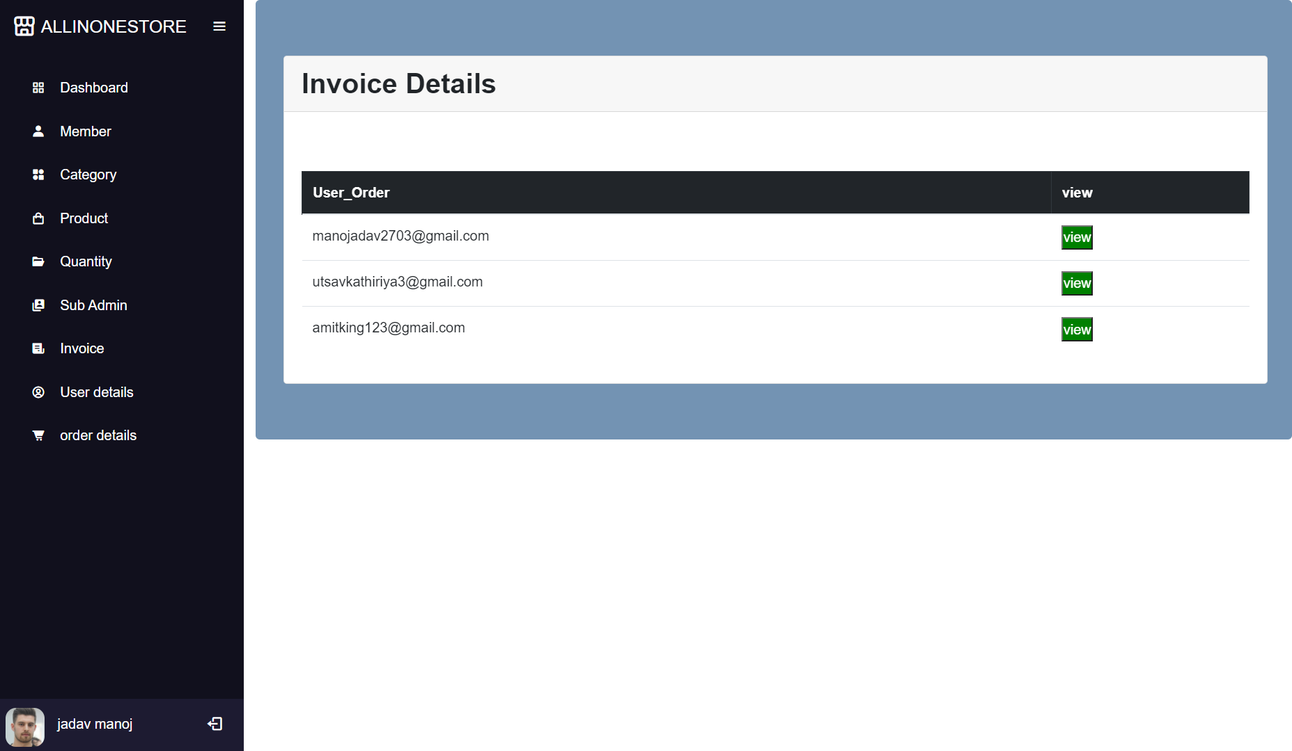

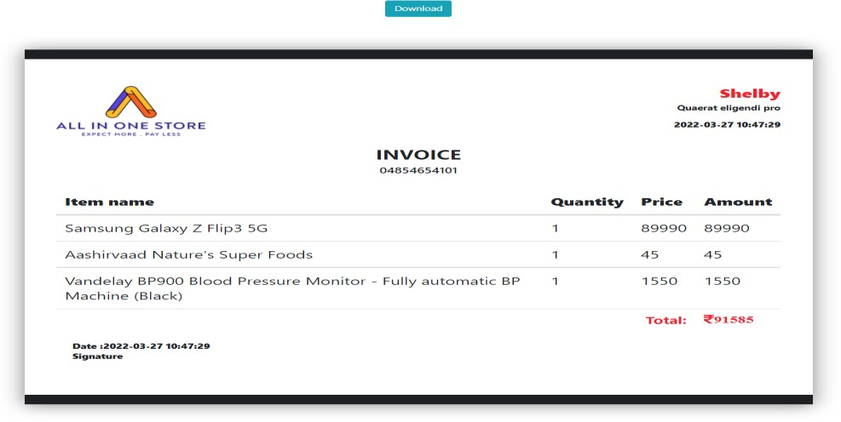

**[ Admin side invoice manage page ]**



1. **User page:**

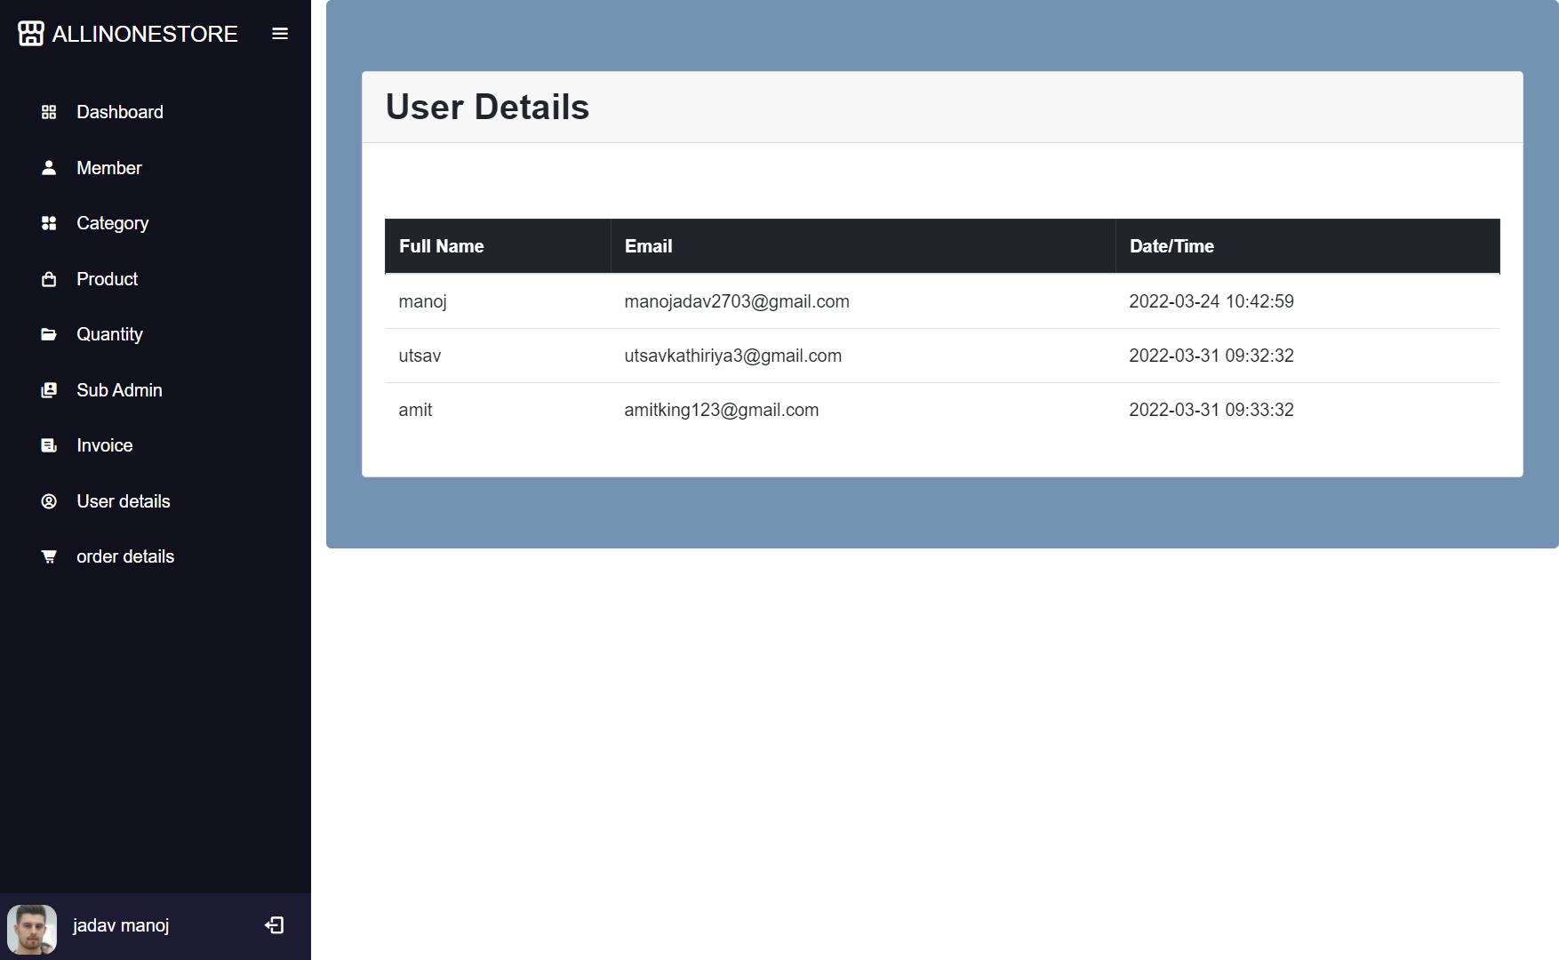

**[ Admin side User page ]**



1. **Order details page:**

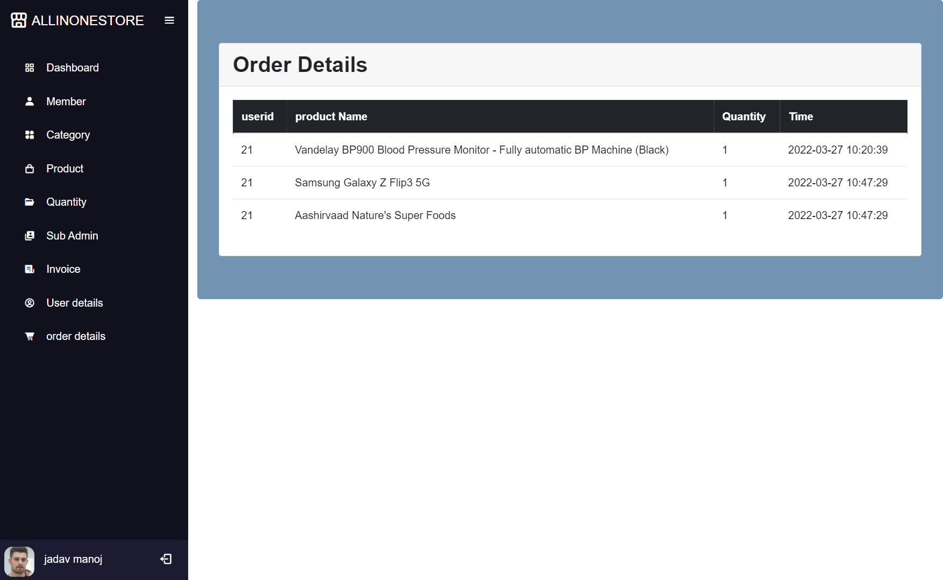

**[ Admin side Order details page ]**



# 2.Sub-admin Side

1. **Sub-admin login :**



**[ Sub-admin Login Page ]**



1. **Sub-admin dashboard :**

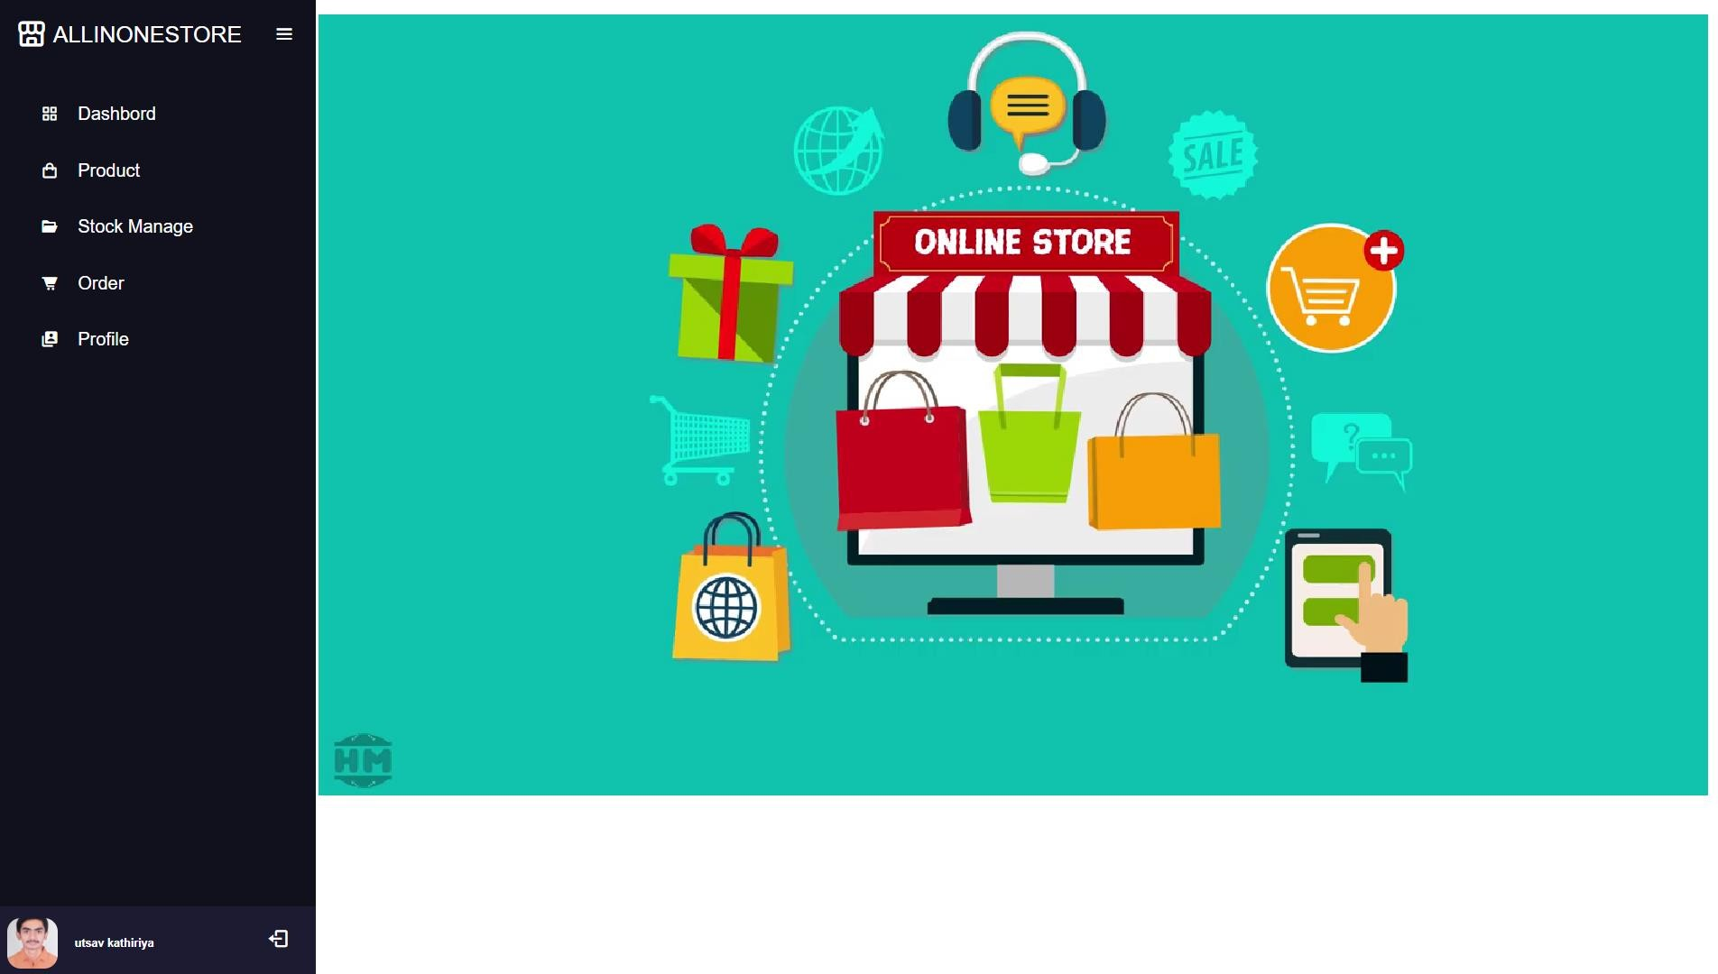

**[ Sub-admin side dashboard page ]**

1. **Sub-admin product page :**

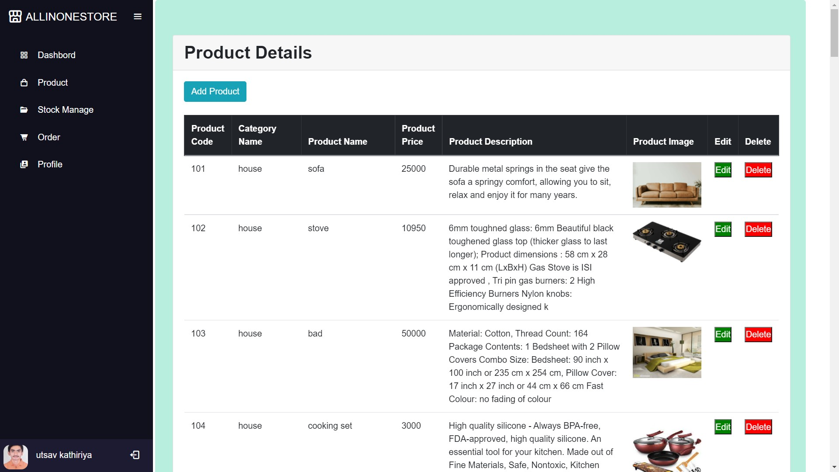

**[sub-admin product page]**



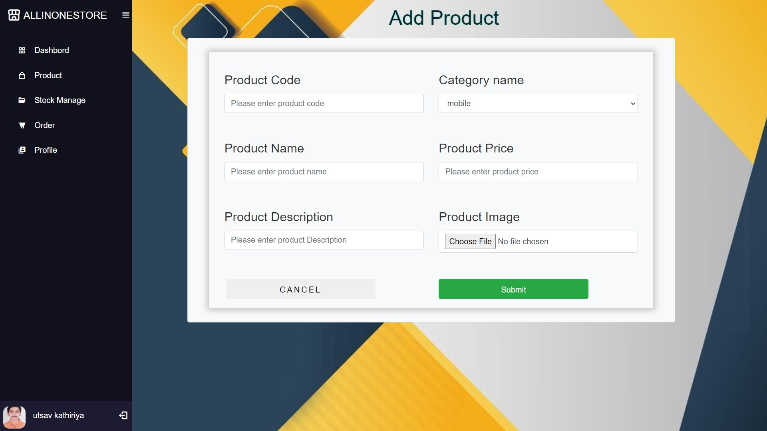

**[ sub-admin add product page ]**



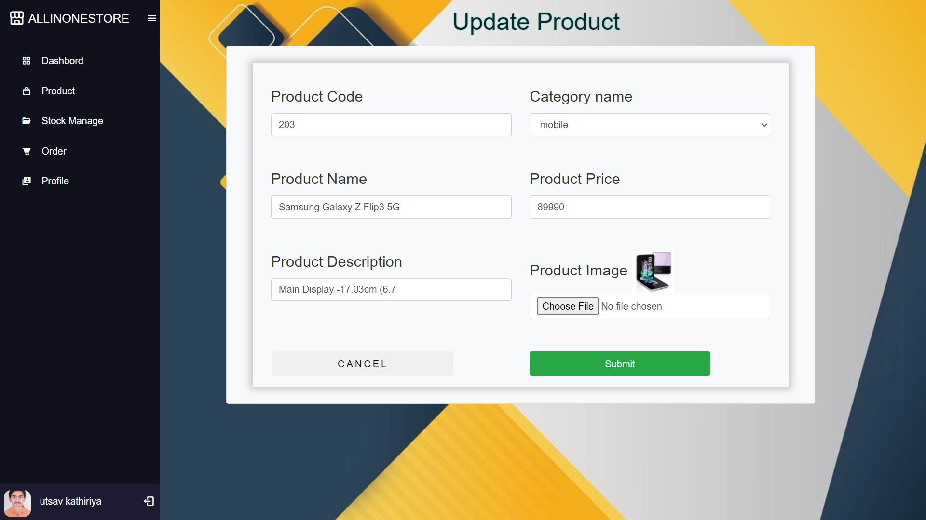

**[ sub-admin update product page ]**



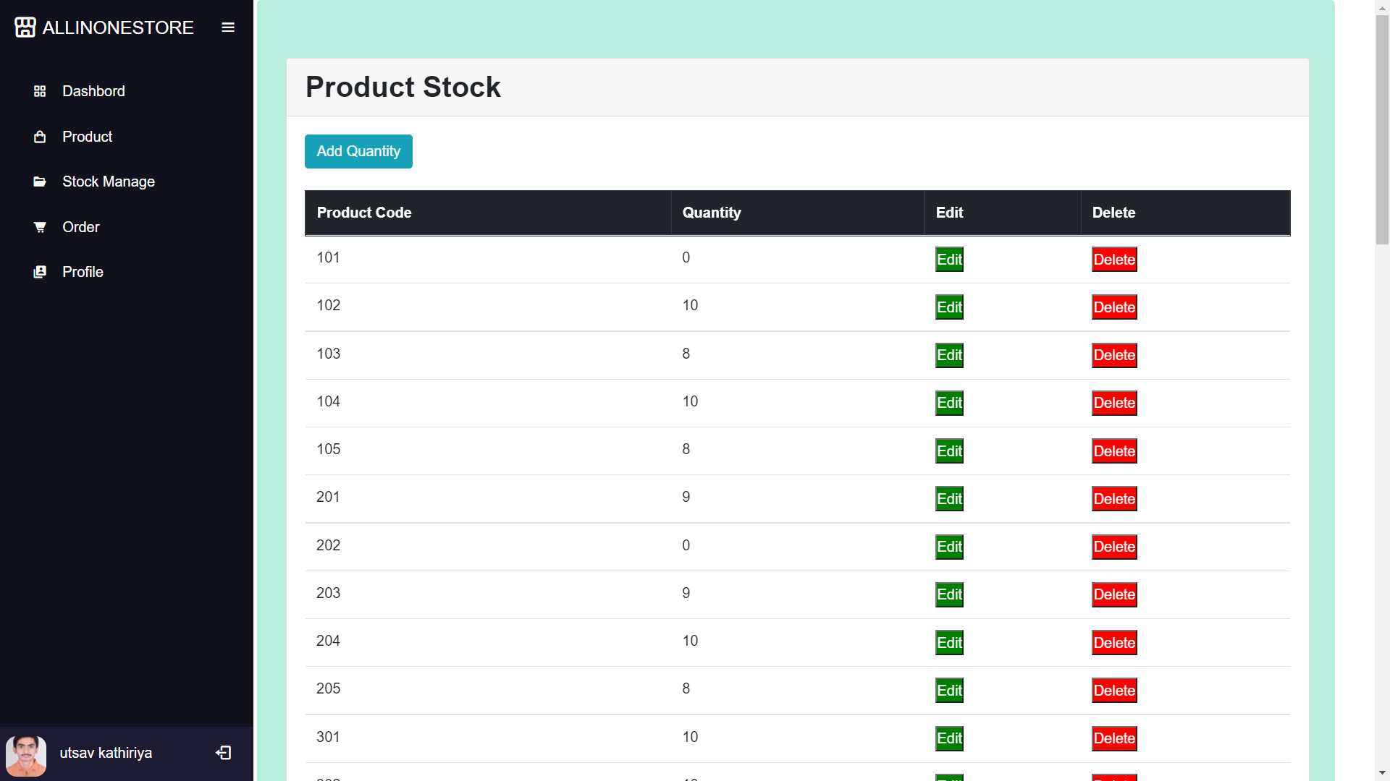

**[ sub-admin stock manage page]**



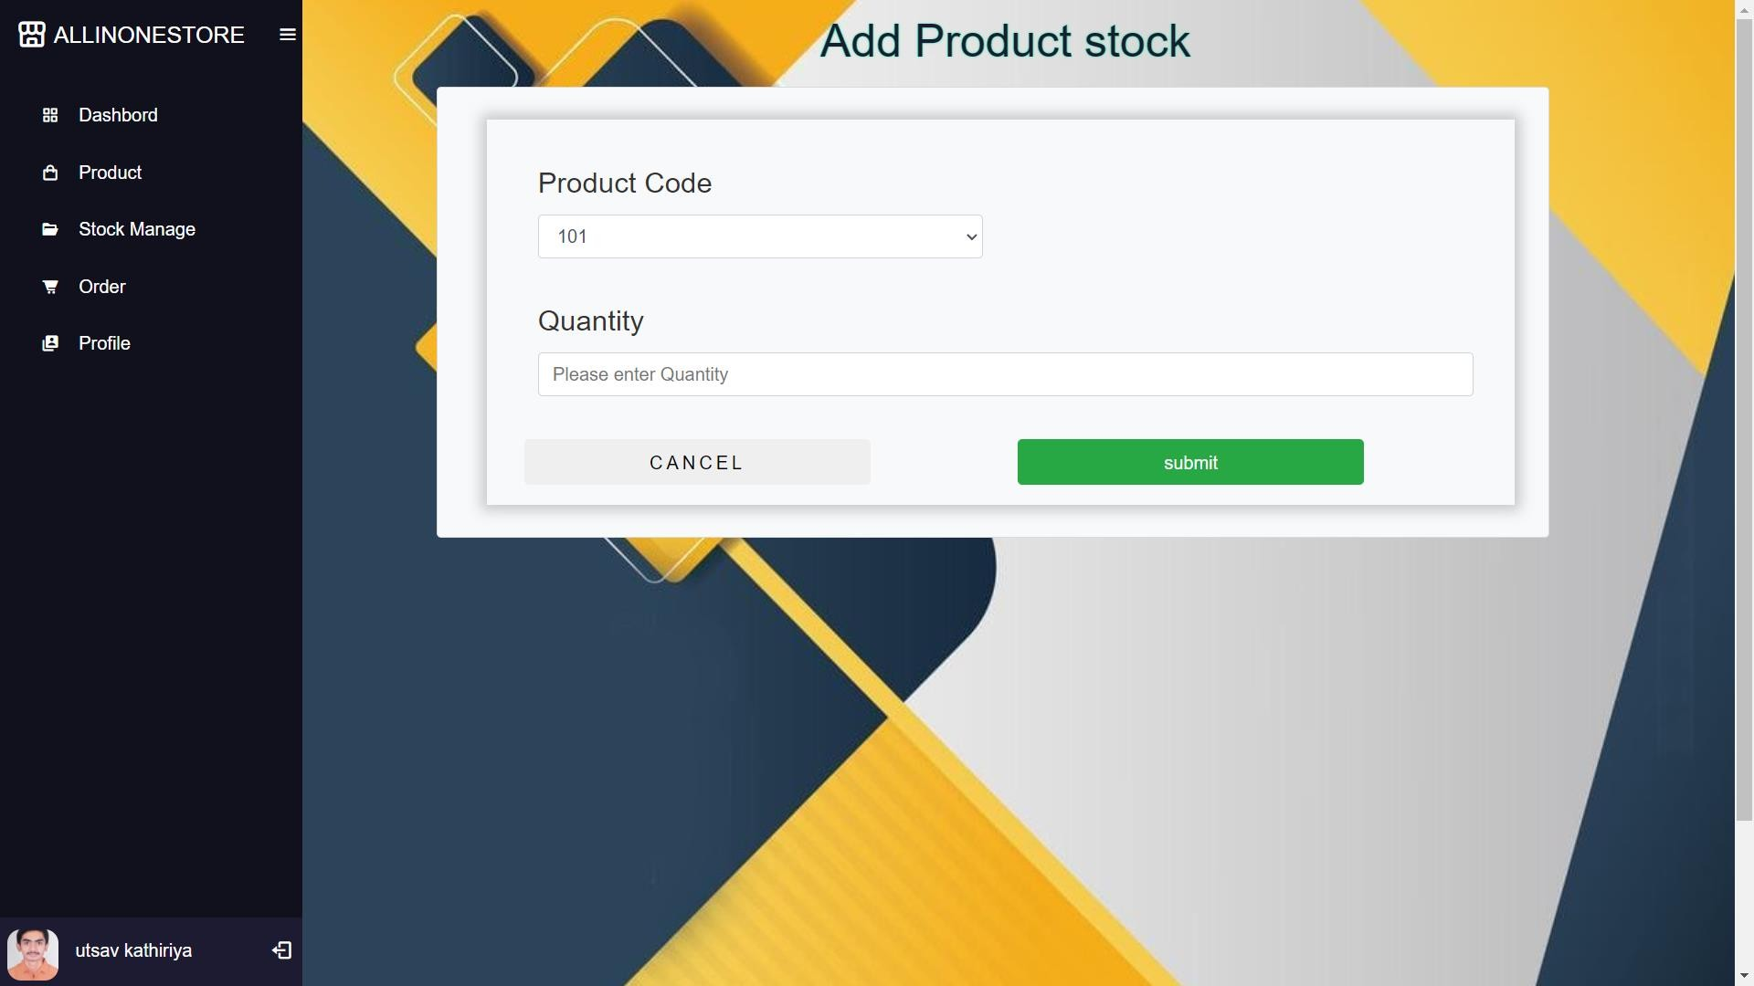

**[sub-admin add product stock page ]**



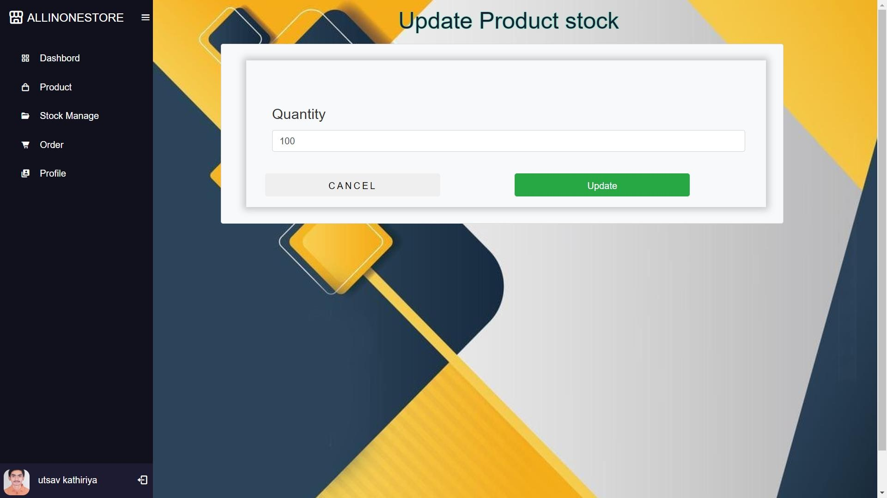

**[sub-admin update product stock page ]**

1. **Sub-admin stock manage:**

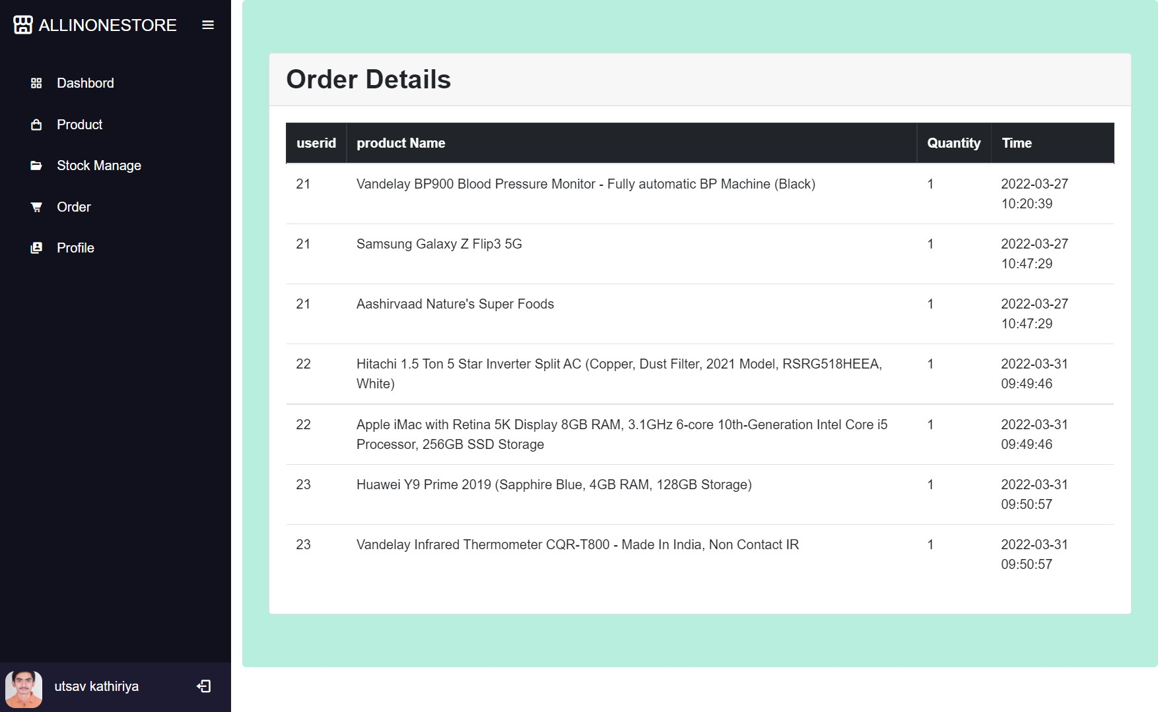

**[sub-admin order page ]**



1. **Sub-admin profile :**

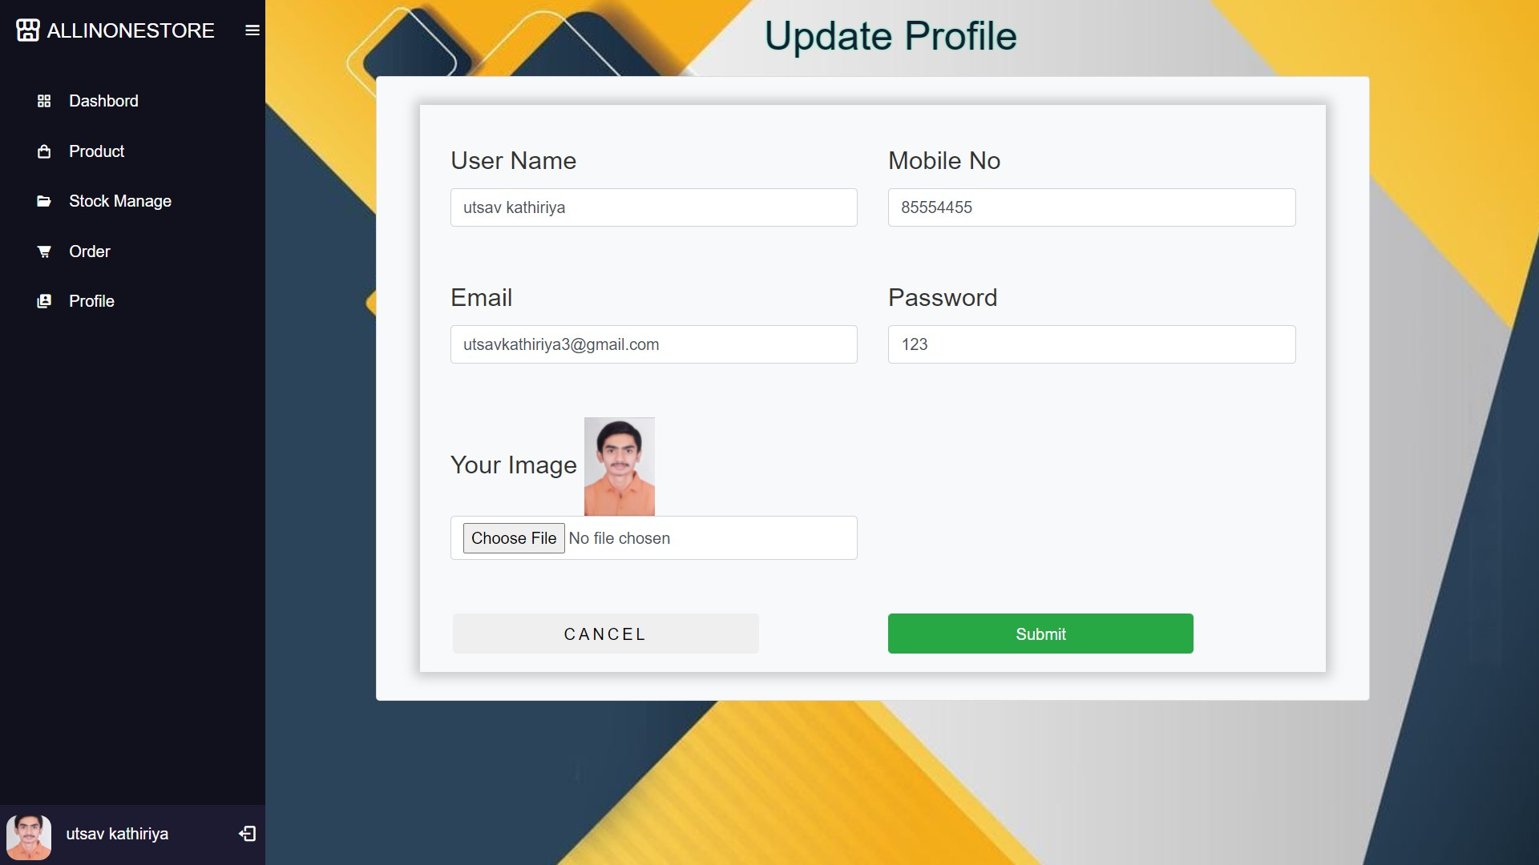

**[sub-admin profile page ]**



# 3.User Side

1. **User registration from :**

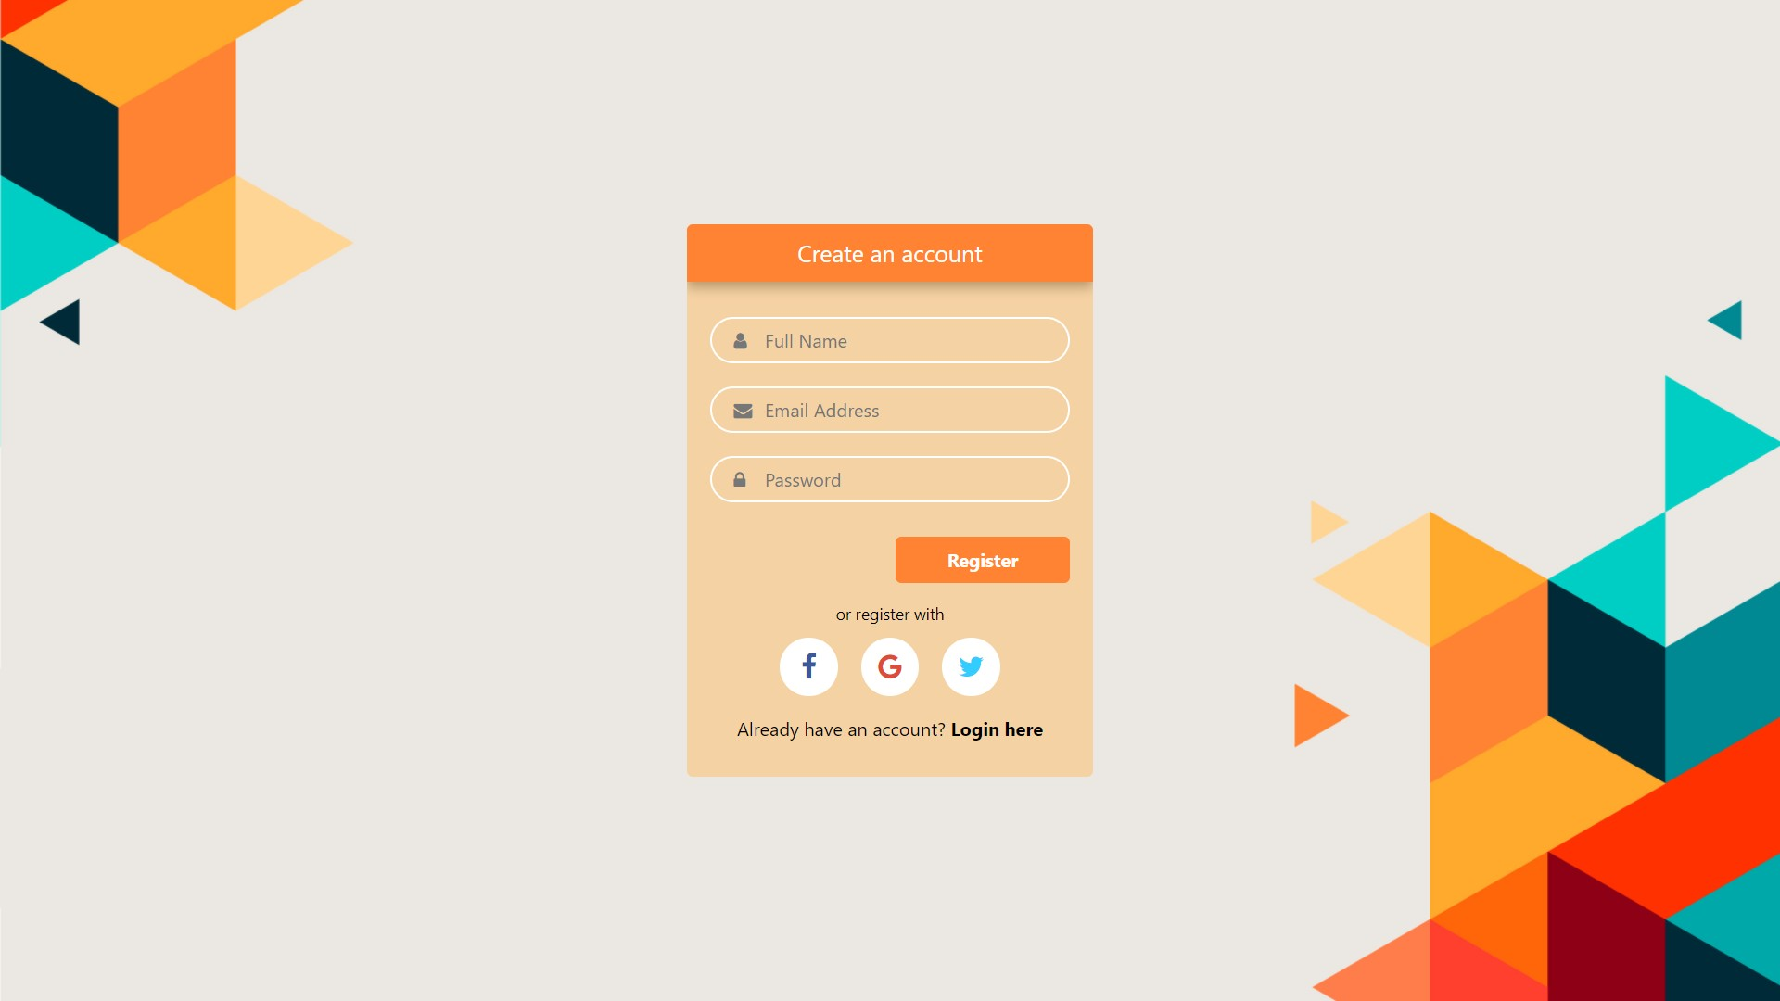

**[User registration page ]**

1. **User login :**

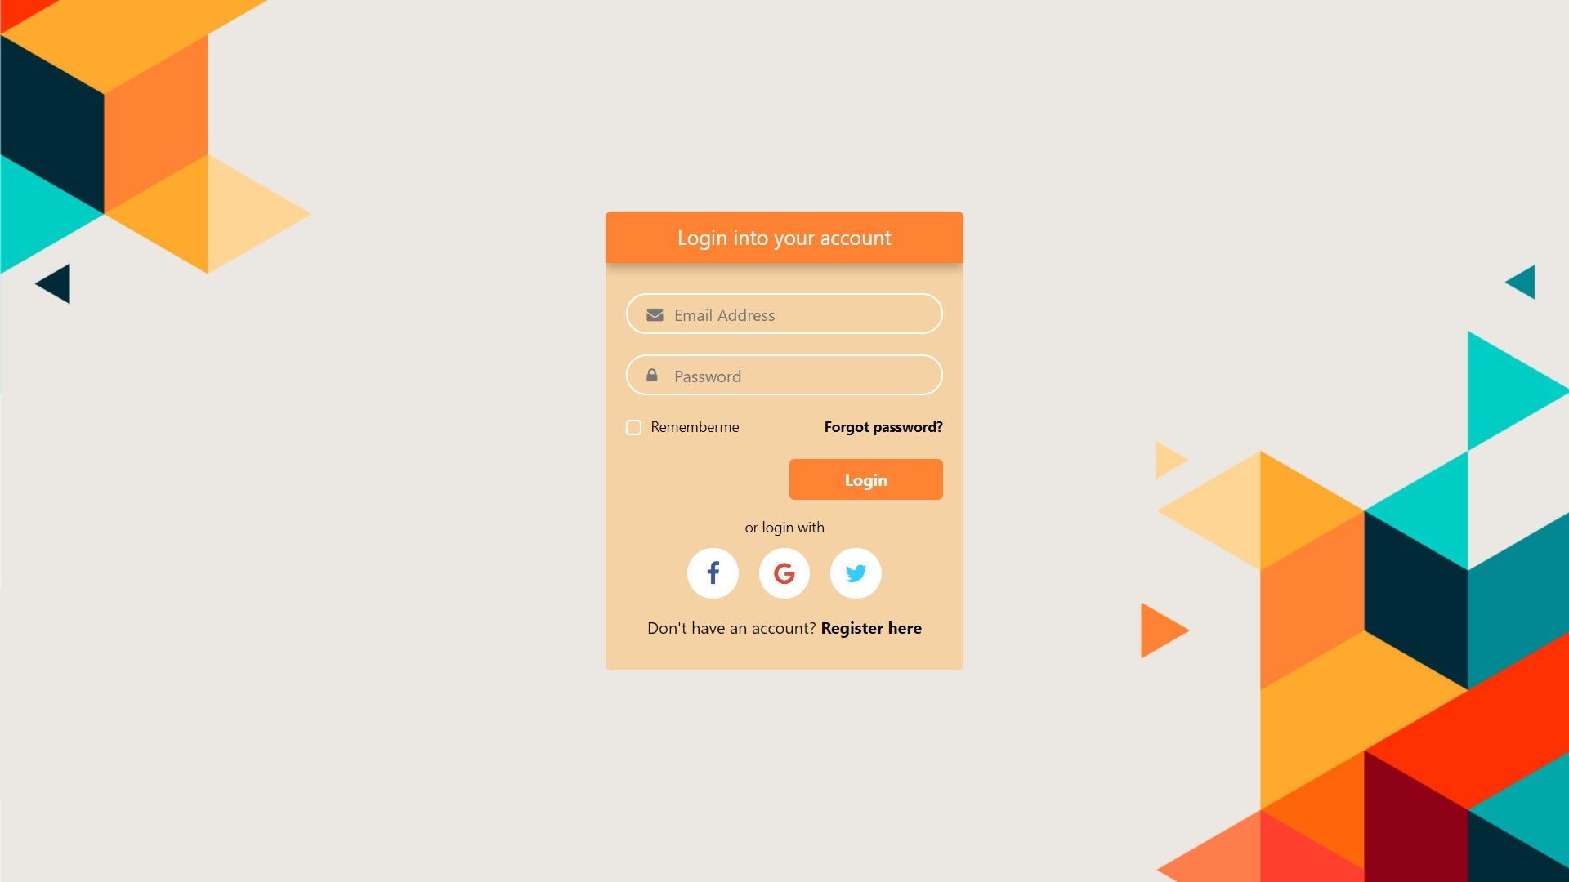

**[User login page ]**

1. **User forget password :**

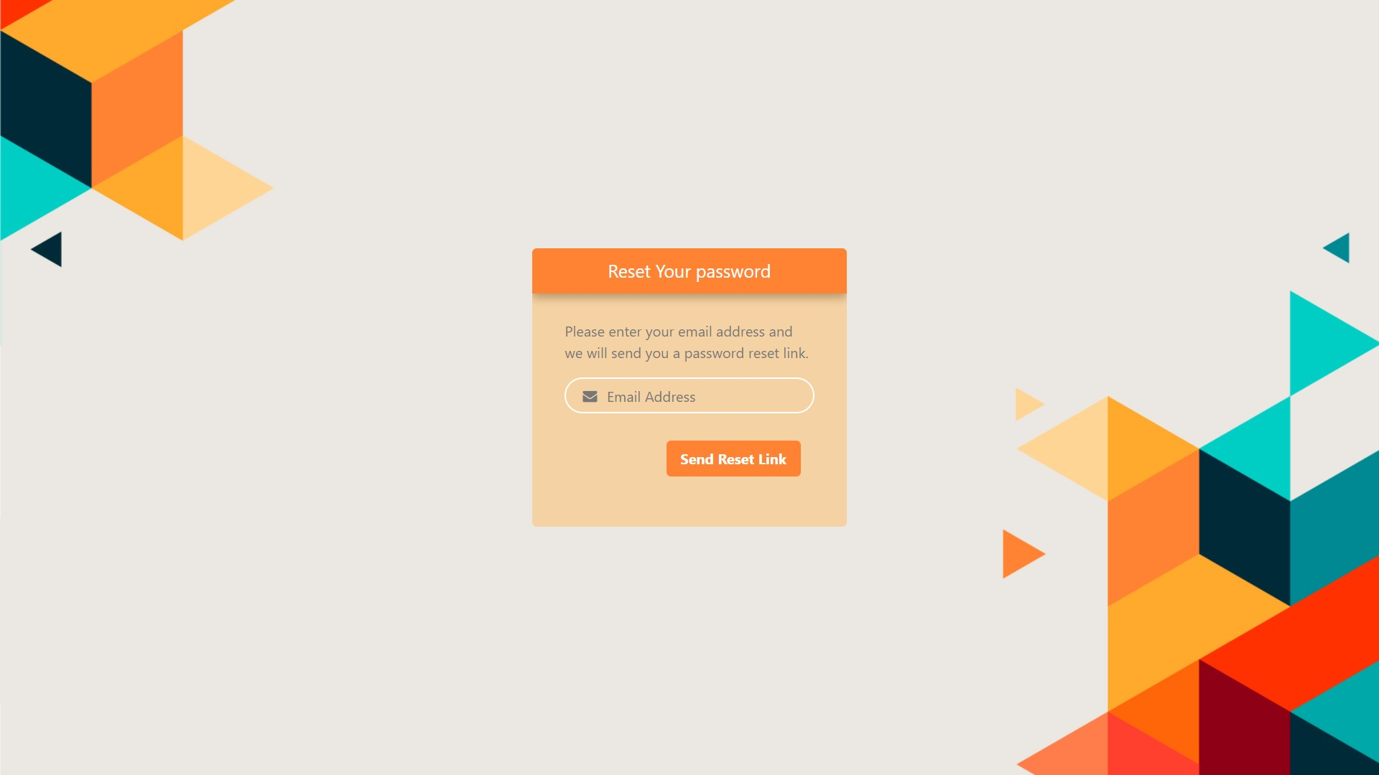

**[ User forget password page ]**

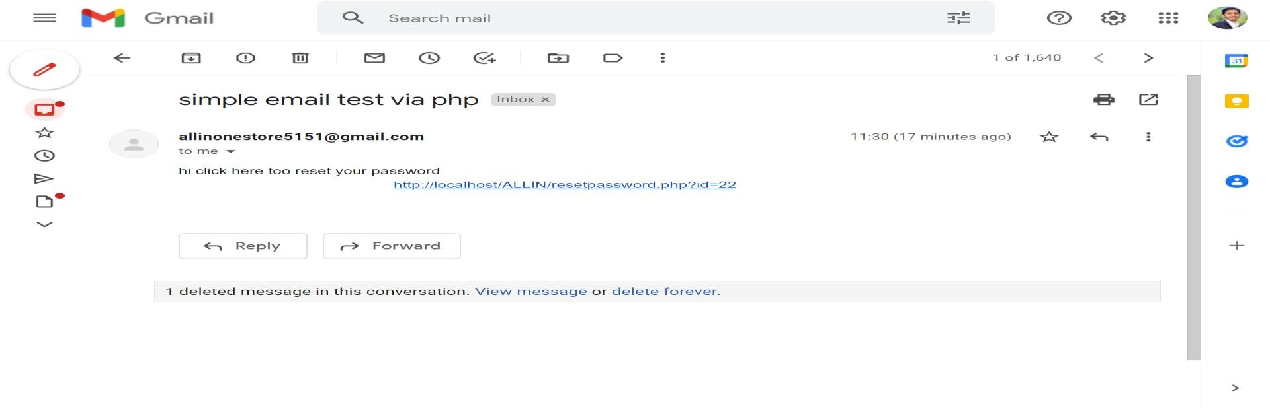

**[ User get in your mail id]**

1. **User side home page:**

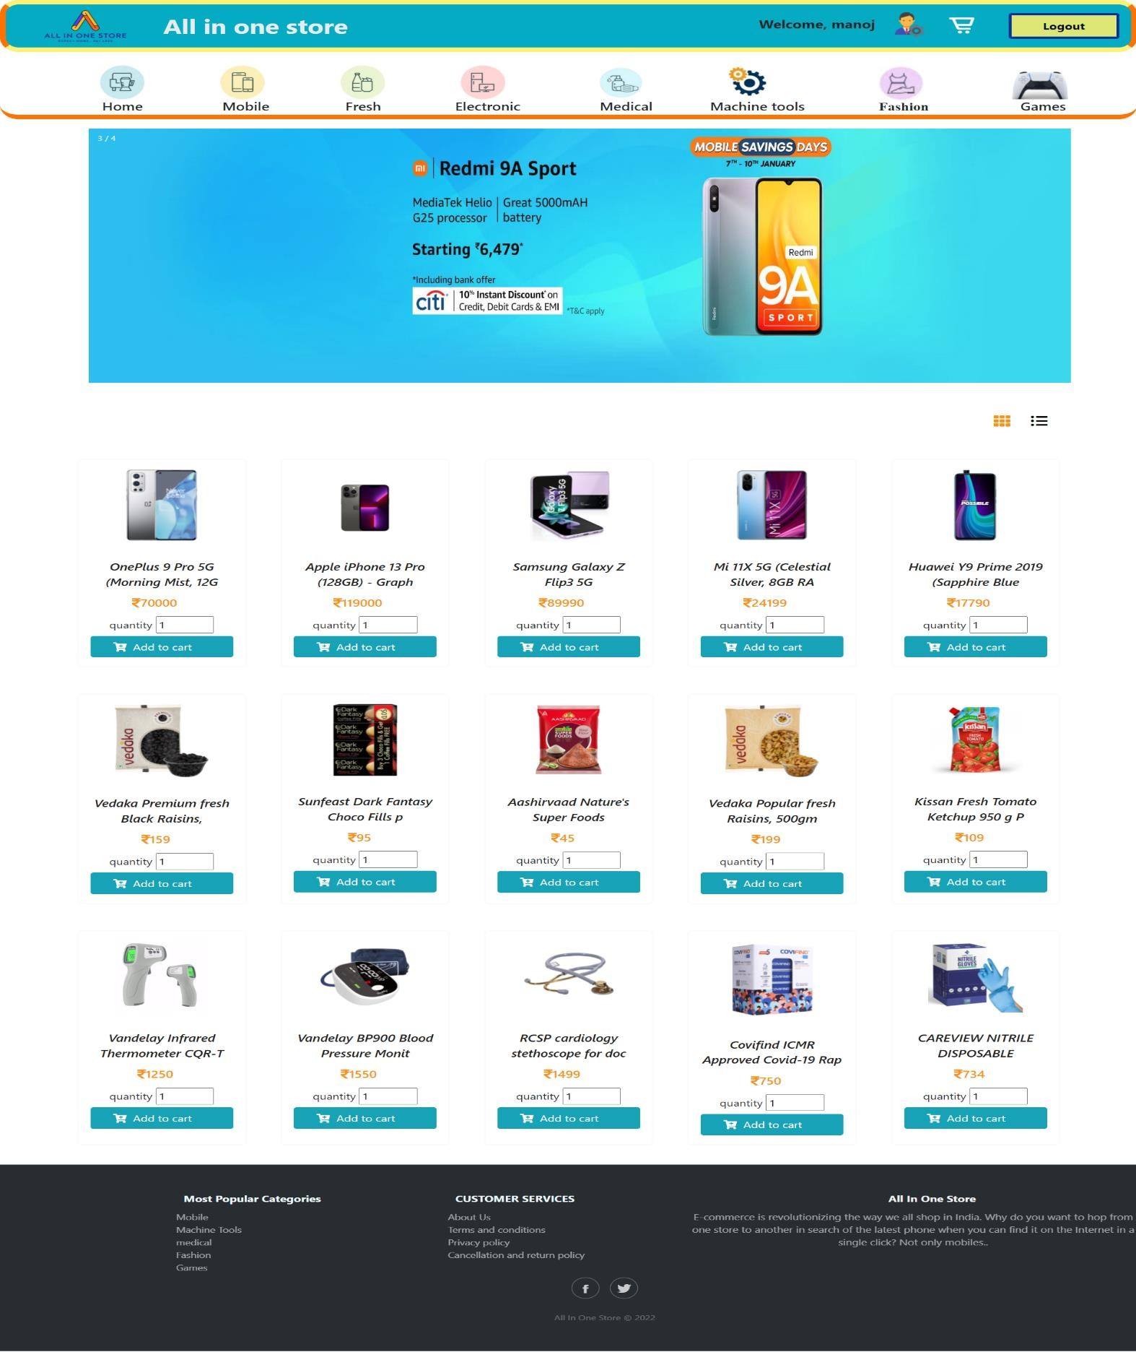

**[ User side home page]**



1. **User side category product page :**

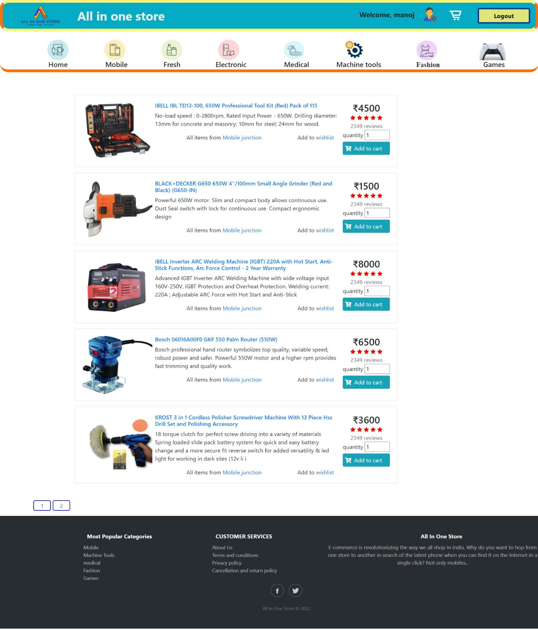

**[ User side category product page]**

1. **User side particular product page:**

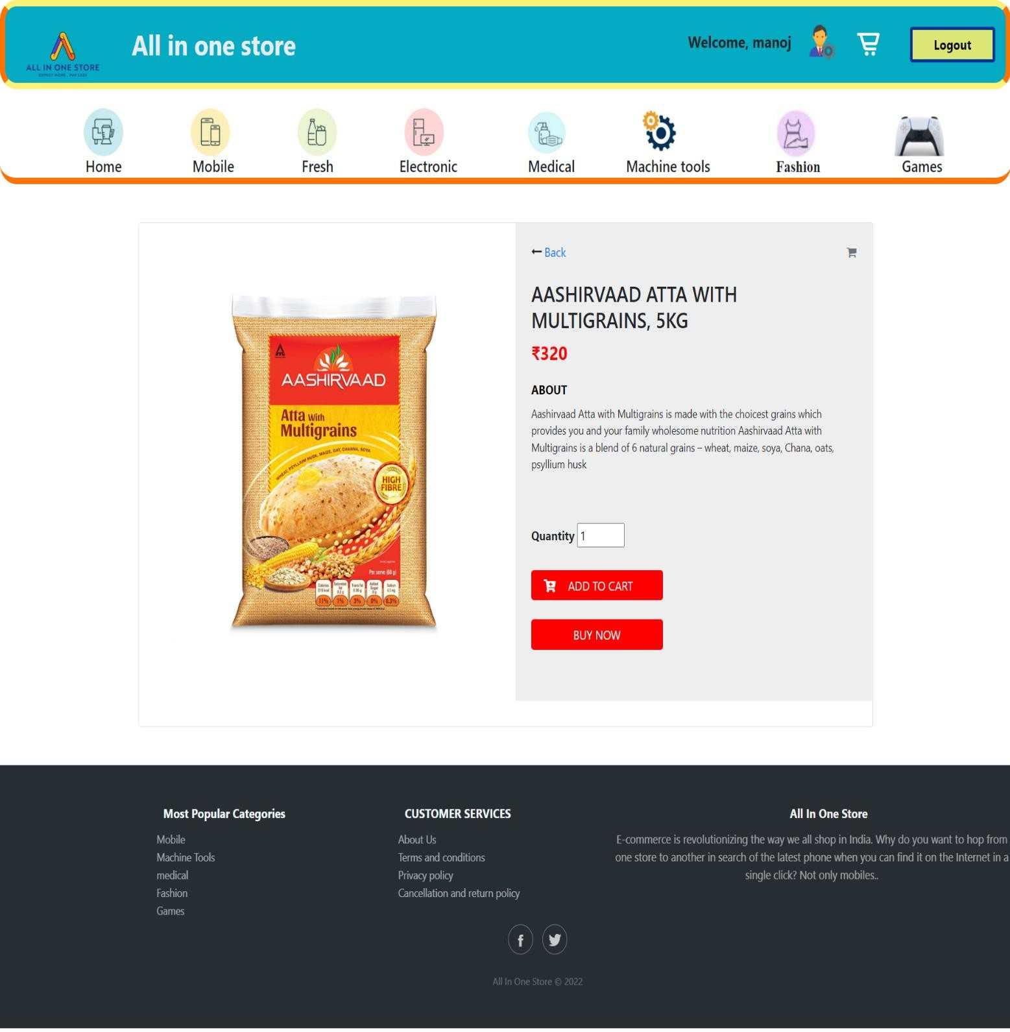

**[User side particular product page]**

1. **User side add to cart:**

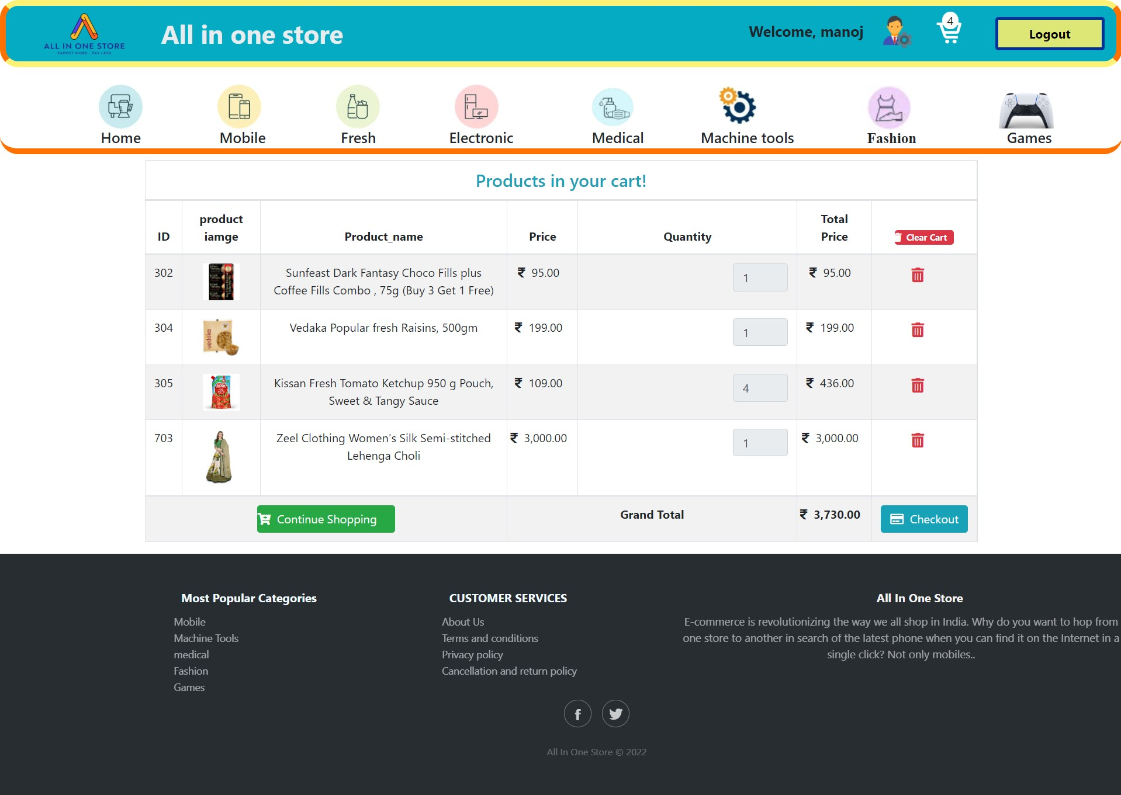

**[User side add to cart page]**



**6. User side checkout from:**

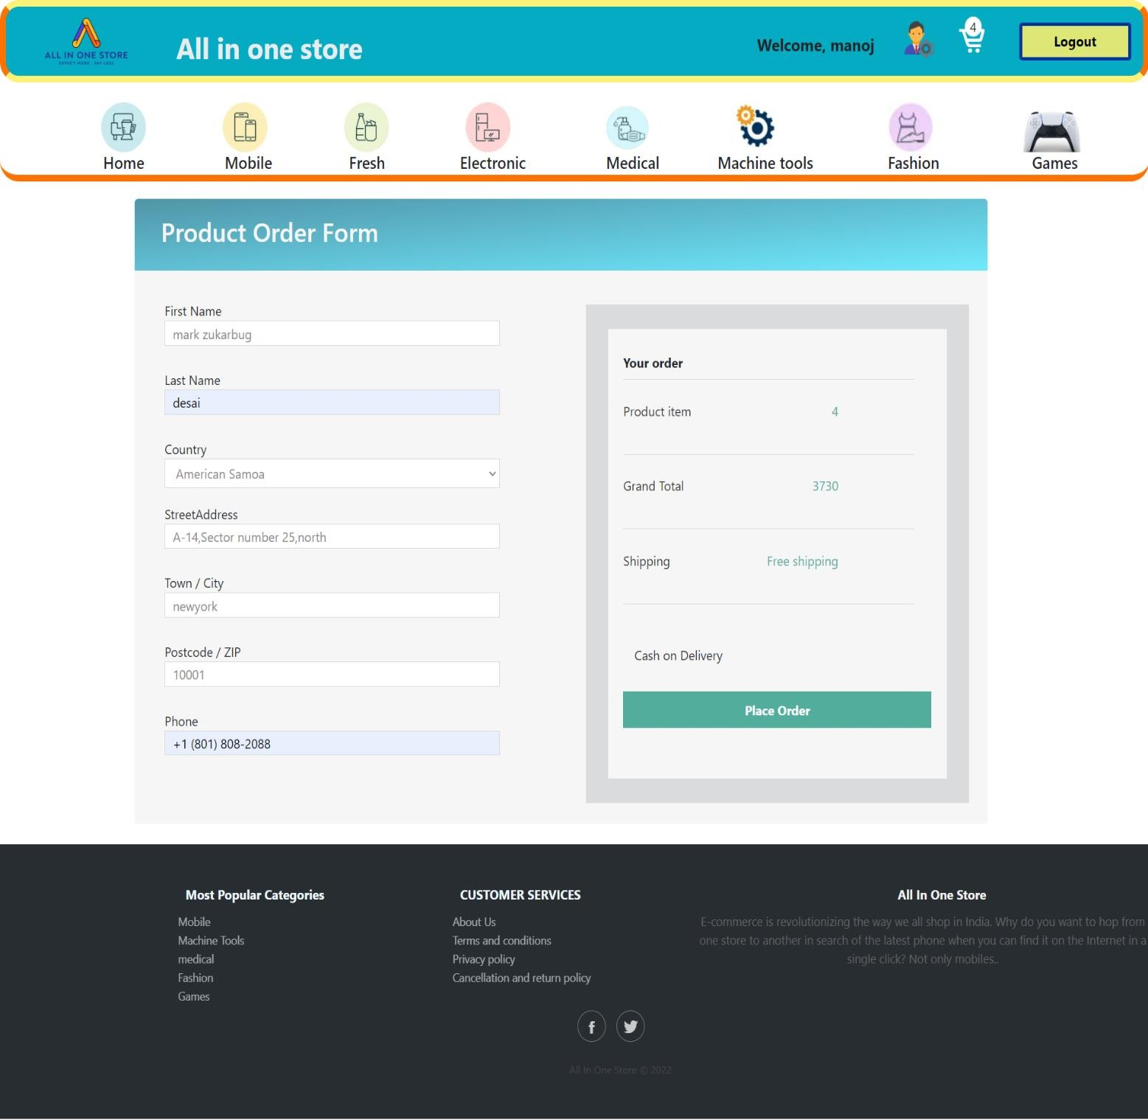

**[User side checkout from page]**

1. **User side order place:**

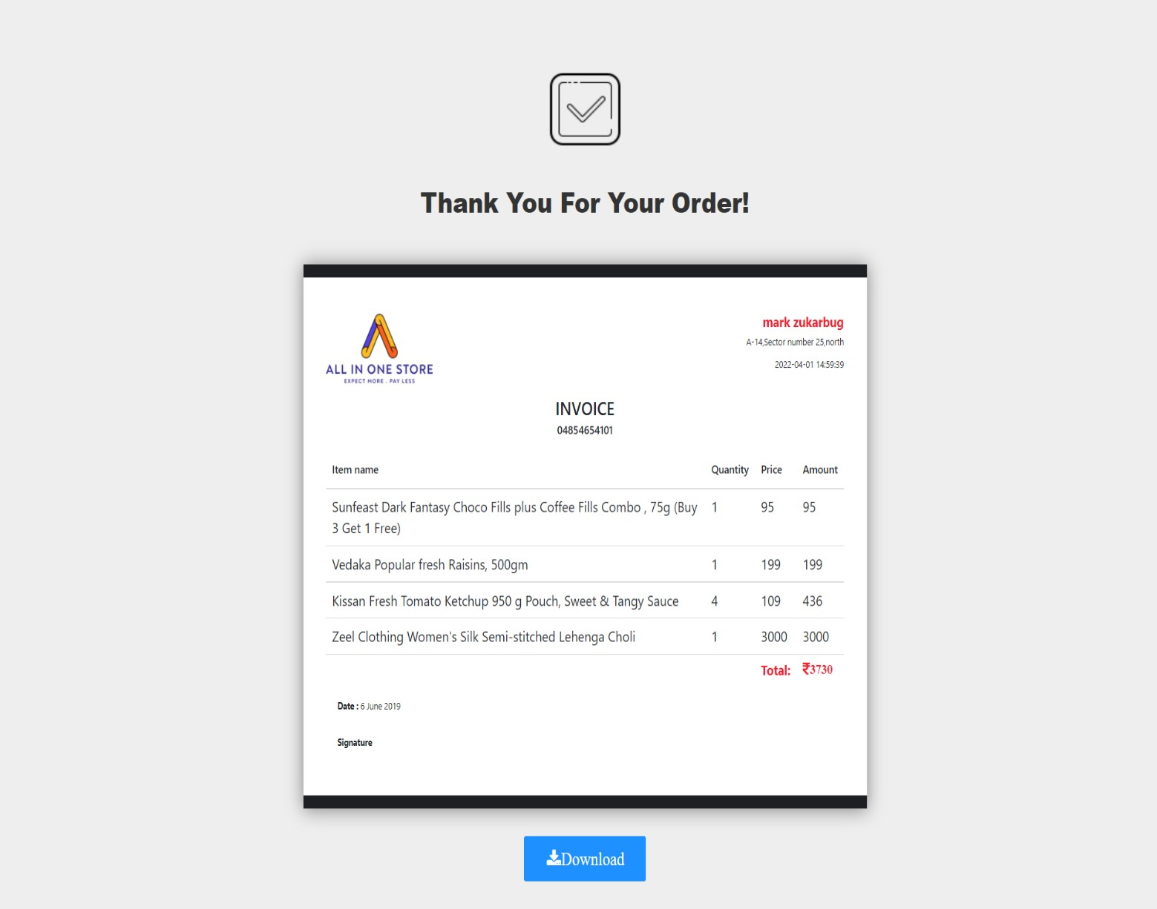

**[User side order place page]**

* 1. **Testing**
  2. Unit Testing

1. **Admin Testing**

**Test Case for Admin – Login**

|  |  |  |  |  |
| --- | --- | --- | --- | --- |
| Test Id | Test field | Step Execute | Executed Result | Actual Result |
| 1 | E-mail | Empty Or Wrong | Msg. ‘please correct Your  Email or password | As Expected |
| 2 | Password | Empty | Msg. ‘please correct Your Email or  password | As Expected |

**Test Case for Admin - Change Password**

|  |  |  |  |  |
| --- | --- | --- | --- | --- |
| Test Id | Test field | Step Execute | Executed Result | Actual Result |
| 1 | New Password | Empty Or Wrong | Msg. ‘Please Enter password Only’ | As Expected |



**Test Case for Admin – Member**

|  |  |  |  |  |
| --- | --- | --- | --- | --- |
| Test Id | Test field | Step Execute | Executed Result | Actual Result |
| 1 | fullname | Empty Or Invalid Or Already Exists | Msg.’please fill out this filed. | As Expected |
| **2** | email | Empty Or Invalid | Msg.’please fill out this filed. | As Expected |
| **3** | password | Empty | Msg.’please fill out this filed. | As Expected |
| **4** | Contact no | Empty Or Invalid | Msg.’please fill out this filed. | As Expected |
| **5** | gender | Select option | Msg’please select option in list’ | As Expected |
| **6** | Profile image | Empty | Please select a file | As Expected |

**Test Case for Admin - Category**

|  |  |  |  |  |
| --- | --- | --- | --- | --- |
| Test Id | Test field | Step Execute | Executed Result | Actual Result |
| 1 | Category id | Empty Or Invalid Or Already Exists | Msg.’ please fill  out this filed. | As Expected |
| **2** | Category name | Empty Or Invalid | Msg.’ Please fill out this  filed. | As Expected |

**Test Case for Admin - Product**

|  |  |  |  |  |
| --- | --- | --- | --- | --- |
| Test Id | Test field | Step Execute | Executed Result | Actual Result |
| 1 | Product code | Empty Or Invalid Or Already Exists | Msg. ’please fill  out this filed. | As Expected |
| **2** | Product name | Empty | Msg.  ’please fill out this filed. | As Expected |
| **3** | Product description | Empty | Msg. ’please fill  out this filed. | As Expected |
| **4** | Category name | Empty | Msg. ’please fill  out this filed. | As Expected |
| **5** | Product price | Empty Or Invalid | Msg. ’please fill out  this filed. | As Expected |
| **6** | Product image | Empty | Msg Please select a file | As Expected |



**Test Case for Admin – product stock**

|  |  |  |  |  |
| --- | --- | --- | --- | --- |
| Test Id | Test field | Step Execute | Executed  Result | Actual Result |
| 1 | Product code | Empty | Msg. ‘Please fill out this filed. | As Expected |
| **2** | Quantity | Empty | Msg. ‘Please  fill out this filed. | As Expected |

**Test Case for Admin – sub-admin**

|  |  |  |  |  |
| --- | --- | --- | --- | --- |
| Test Id | Test field | Step Execute | Executed Result | Actual Result |
| 1 | fullname | Empty | Msg. ‘Please fill out this filed. | As Expected |
| **2** | Contact no | Empty | Please  fill out this filed. | As Expected |
| **3** | email | Empty | Please  fill out this filed. | As Expected |
| **4** | gender | Empty | Msg’ please select option in list’ | As Expected |
| **5** | image | Empty | Please select a file | As Expected |



1. Sub-admin Testing

**Test Case for Sub-admin – Login**

|  |  |  |  |  |
| --- | --- | --- | --- | --- |
| Test Id | Test field | Step Execute | Executed Result | Actual Result |
| 1 | E-mail | Empty Or Wrong | Msg. ‘please correct Your  Email or password | As Expected |
| 2 | Password | Empty | Msg. ‘please correct Your Email or  password | As Expected |

**Test Case for Sub-Admin - Change Password**

|  |  |  |  |  |
| --- | --- | --- | --- | --- |
| Test Id | Test field | Step Execute | Executed Result | Actual Result |
| 1 | New Password | Empty Or Wrong | Msg. ‘Please Enter password Only’ | As Expected |



**Test Case for Sub-Admin - Product**

|  |  |  |  |  |
| --- | --- | --- | --- | --- |
| Test Id | Test field | Step Execute | Executed Result | Actual Result |
| 1 | Product code | Empty Or Invalid Or Already Exists | Msg. ’please fill  out this filed. | As Expected |
| **2** | Product name | Empty | Msg.  ’please fill out this filed. | As Expected |
| **3** | Product description | Empty | Msg. ’please fill  out this filed. | As Expected |
| **4** | Category name | Empty | Msg. ’please fill  out this filed. | As Expected |
| **5** | Product price | Empty Or Invalid | Msg. ’please fill out  this filed. | As Expected |
| **6** | Product image | Empty | Msg Please select a file | As Expected |

**Test Case for Sub-Admin – product stock**

|  |  |  |  |  |
| --- | --- | --- | --- | --- |
| Test Id | Test field | Step Execute | Executed  Result | Actual Result |
| 1 | Product code | Empty | Msg. ‘Please fill out this filed. | As Expected |
| **2** | Quantity | Empty | Msg. ‘Please  fill out this filed. | As Expected |



1. User Testing:

**Test Case for User – Registration**

|  |  |  |  |  |
| --- | --- | --- | --- | --- |
| Test Id | Test field | Step Execute | Executed Result | Actual Result |
| 1 | Full name | Empty Or Wrong | Msg. ‘Please fill out this  field’ | As Expected |
| **2** | Email address | Empty or Wrong | Msg. ‘Please fill out this field’ | As Expected |
| 3 | password | Empty | Msg. ‘Please  fill out this field’ | As Expected |

**Test Case for User – Login**

|  |  |  |  |  |
| --- | --- | --- | --- | --- |
| Test Id | Test field | Step Execute | Executed Result | Actual Result |
| 1 | Email address | Empty Or Wrong | Msg. ‘Please  fill out this field’ | As Expected |
| 2 | password | Empty or Invalid | Msg. ‘Please  fill out this field’ | As Expected |

**Test Case for User – Add to cart product**

|  |  |  |  |  |
| --- | --- | --- | --- | --- |
| Test Id | Test field | Step Execute | Executed  Result | Actual Result |
| 1 | Product | Empty | Msg. ‘Please  Choose product | As Expected |
| **2** | Quantity | Empty | Msg. Please  Enter Quantity | As Expected |



**Test Case for User – Buy now product**

|  |  |  |  |  |
| --- | --- | --- | --- | --- |
| Test Id | Test field | Step Execute | Executed Result | Actual Result |
| 1 | Product | Empty | Msg. ‘Please  Choose product | As Expected |
| **2** | Quantity | Empty | Msg. Please Enter  Quantity | As Expected |

**Test Case for User – Checkout**

|  |  |  |  |  |
| --- | --- | --- | --- | --- |
| Test Id | Test field | Step Execute | Executed Result | Actual Result |
| 1 | First Name | Empty o | Msg. ‘Please fill out this  field’ | As Expected |
| **2** | Last Name | Empty | Msg. ‘Please fill out this  field’ | As Expected |
| **3** | Country | Empty | Msg. ‘Please  fill out this field’ | As Expected |
| **4** | Street address | Empty | Msg. ‘Please  fill out this field’ | As Expected |
| **5** | Town/City | Empty | Msg. ‘Please  fill out this field’ | As Expected |
| **6** | Postcode/zip | Empty | Msg. ‘Please fill out this field’ | As Expected |
| **7** | phone | Empty | Msg. ‘Please fill out this  field’ | As Expected |



* 1. **Navigation Testing**

**Admin**

|  |  |  |
| --- | --- | --- |
| **Link** | Expected Page | Result Of Page |
| **Admin Login** | Admin Login page | Admin Login Page |
| **Admin Edit Profile** | Admin Edit Profile Page | Admin Edit Profile Page |
| **Admin Change Password** | Admin Change Password Page | Admin Change Password Page |
| **Admin Dashboard** | Admin Dashboard Page | Admin Dashboard Page |
| **Category** | CategoryPage | CategoryPage |
| **Member** | Member page | Member page |
| **Product** | product Page | product Page |
| **Sub-admin** | Sub-admin Page | Sub-admin Page |
| **Product stock** | Product stock page | Product stock page |
| **invoice** | Invoice page | Invoice page |



Sub-admin :

|  |  |  |
| --- | --- | --- |
| **Link** | Expected Page | Result Of Page |
| **Sub-admin Login** | Sub-admin Login page | Sub-admin Login page |
| **Sub-admin Edit Profile** | Sub-admin Edit Profile Page | Sub-admin Edit Profile Page |
| **Admin Change Password** | Admin Change Password Page | Admin Change Password Page |
| **Sub-admin Dashboard** | Sub-admin Dashboard Page | Sub-admin Dashboard Page |
| **Product** | product Page | product Page |
| **Product stock** | Product stock page | Product stock page |

User :

|  |  |  |
| --- | --- | --- |
| **Link** | Expected Page | Result Of Page |
| **User Registration** | User Registration Page | User Registration Page |
| **User Login** | User Login page | User Login Page |
| **User Home** | User Home Page | User Home Page |
| **Category View** | CategoryView Page | CategoryView Page |
| **Product view** | Product View Page | Product View Page |
| **Admin login View** | Admin login ViewPage | Admin login ViewPage |
| **Sub-admin login View** | Sub-admin login View page | Sub-admin login View page |

|  |  |  |
| --- | --- | --- |
| **Add to cart View** | Add to cart view Page | Add to cart view Page |
| **Checkout** | Checkout ViewPage | Checkout ViewPage |
| **About us View** | About View Page | About View Page |
| **Terms & Condition View** | Terms & Condition View Page | Terms & Condition View Page |
| **Privacy policy** | Privacy policy ViewPage | Privacy policy ViewPage |





* 1. Functional Testing
     + Login and Password validation process has been co-operated properly.
     + Email system module has been done properly and accurately.
     + Sending Forgot Password through mails is working properly.
     + Visibility of category wise product are working Properly.
     + User registration is working Properly.
     + Product stock manage properly.
     + Invoice download pdf format is working properly.
     + File Upload Images work properly
     + Notifications of add to cart product Displaying Properly.
     + All Pages Design is perfect.



* 1. Environment Testing
* irefox browser, Internet explorer and chrome consider testing for environment operability of software.
  + eb server – Apache/xampp
  + atabase – MYSQL Server
  + S – Windows 10
  + rowser – Firefox/Internet Explorer/Chrome



#### Conclusion

* Technology has made significant progress over the years to provide consumers a better online shopping experience and will continue to do so for years to come. With the rapid growth of products and brands, people have speculated that online shopping will overtake in-store shopping.
* While this has been the case in some areas, there is still demand for brick and mortar stores in market areas where the consumer feels more comfortable seeing and touching the product being bought. However, the availability of online shopping has produced a more educated consumer that can shop around with relative ease without having to spend a large amount of time.
* In exchange, online shopping has opened up doors to many small retailers that would never be in business if they had to incur the high cost of owning a brick and mortar store. At the end, it has been a win-win situation for both consumer and sellers.



#### Bibliography

* ebsite :-
  + [ttps://www.amazon.com/](https://www.amazon.com/)
  + [ttps://www.jiomart.com/](https://www.jiomart.com/)
* **ooks :-**
  + HP & MySQL Novice to Ninja – by Kevin Yank.
  + ead First PHP & MySQL – by Lynn Beighley & Michael Morrison.
  + urach's PHP & MySQL – by Joel Murach & Ray Harris.